SOS – Save Our Spoons!

Online parent support group, SOS - Save Our Spoons (formerly South Staffs CAMHs Online Parent Support Group), has been given a refreshing makeover – just in time for summer!
Save Our Spoons offers a relaxing, safe and supportive environment for families of children with a mental health need living in the South Staffs area.
Run by a mental health practitioner and parent with lived experience, families can get support, guidance and sign-posting, learn new skills, and make friends with people who truly understand.
Chanté (Senior Parent Peer Supporter) and Bethan (Mental Health Practitioner) – who run the group – always welcome new families and listen to what they want from the sessions. There is always the space for sharing experiences and time for asking for support. Sessions are flexible, depending on what families bring to the group each week. In short, the families always come first.
Some sessions offer wellbeing activities whereas others are topic based. They regularly welcome guest speakers and are always looking for more visitors to join them, if anyone has a spare half an hour to come along and talk. Past topics have included Autism, sleep hygiene, anxiety, depression, self-harm, self-care, and local services. Upcoming topics include digital wellbeing, peer volunteer training, and gambling addiction awareness – to name but a few! Visitors have included clinicians, nurses, peer supporters, charity workers and experts by lived experience, such as parents of children and adults who have been through CAMHs themselves.
Please do get in touch if you, or someone you know, is willing to come along and meet our lovely families!
Why the Spoons?!
We’re proud to call ourselves a service that works with and listens to our families. One thought we kept coming back to in our sessions was the Spoon Theory. In a nutshell, the idea is that everyone starts the day with twelve spoons and each activity uses up a certain number of spoons before we eventually ran out and need to recharge our batteries. Different activities use up a different number of spoons, so making breakfast might use up one spoon whereas as cooking a three course meal for six people may use up four or five spoons. You can recuperate spoons by doing things like resting, sleeping, exercising or taking a bath.
But what happens if you don’t start the day with 12 spoons? For people whose children have a physical or mental health need they may start the day with only eight spoons. What if they have a chronic illness themselves? Or are a single parent family? Or have more than one child with additional needs? Well that’s several more spoons gone before you even get started. It’s no wonder so many families in our group feel like they are running on empty!
We began to regularly hear phrases like ‘I’m low on spoons today!’, ‘I woke up and only had three spoons.’, or ‘I’ve got no more spoons left to give.’ Hence, Save Our Spoons was born (we liked the acronym too!).
What do Our Families Think?
We regularly ask for feedback from our families to ensure that we are meeting their needs; the group is fluid and continually evolving. Here’s what some of our parents had to say:
‘It’s good to be able to give feedback. It felt good to have a voice. I think parent support is vital, and any groups that offer this are very needed and help the family as a whole.’
‘It was helpful to have a space to pause and reflect as a parent - I don't have many opportunities to do that as I tend to be supporting others. I also found it a useful networking session.’
‘That peer support thing that happens is so empowering and it has this really beautiful authenticity, which you just can't get from a textbook.’
‘Having options for online sessions seem to really help.’
‘I want you to know how thankful I am, and how brilliant I think the sessions have been. The support from yourselves and the other mums has been wonderful.’
‘It’s the highlight of my week!’
What does the Future Hold for Save Our Spoons?
We have lots of exciting things up our sleeve – more guest speakers, celebrations, summer pop-up sessions and more! Our big plans for the future include adding more regular sessions to enable more parents to access our support at different times and getting parents involved by becoming parent peer support volunteers – if you’re interested in volunteering, please get in touch!
How Do I Join?
Currently we offer our group Wednesdays in term time, 01:00 PM – 02:30 PM.
You can register to join the group on Zoom in advance using this link or by using our QR code:
https://us02web.zoom.us/meeting/register/tZUof-6tpjkqHdddk6tg8t0Vz7A2_-jcJg62
After registering, you will receive a confirmation email containing information about joining the meeting.
Got Any Questions?
Get in touch via phone, email or on any of our social media channels:
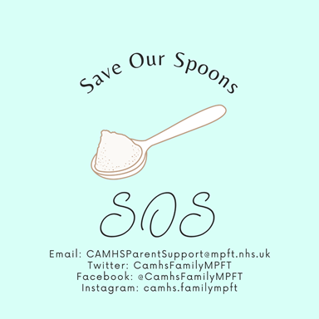
Email: CAMHSParentSupport@mpft.nhs.uk
Twitter: SOS - Save Our Spoons @CamhsFamilyMPFT
Facebook: SOS Save Our Spoons @CamhsFamilyMPFT
Instagram: SOS - Save Our Spoons camhs.familympft
Website: http://camhs.mpft.nhs.uk

Professionals can contact Chanté directly from Wednesday to Friday on:
Chanté’s work phone – 07581026307
Chante.Williamson@mpft.nhs.uk
