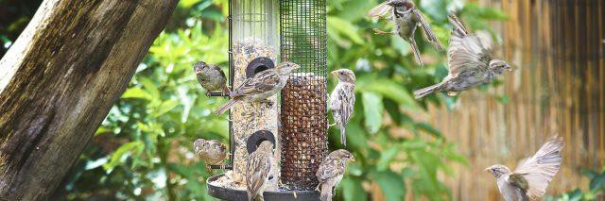

Birdwatching for Wellbeing
Gareth Eccleston and Fiona Moore

mpftnhs

@mpftnhs

GROUP WELCOME
- Come with an open mind and an open heart
- Online life reflects real life; be who you want to be
- We can agree to disagree
- Keep a learning focus
- Share to help others learning
- Be mindful of other students and their experiences

www.mpft.nhs.uk
www.mpft.nhs.uk Together we are making life better for our communities @mpftnhs
Together we are making life better for our communities
@mpftnhs

Using Zoom on a Laptop
To turn on/off microphone/video

Please don’t!
To raise your hand or ‘chat’

Reactions
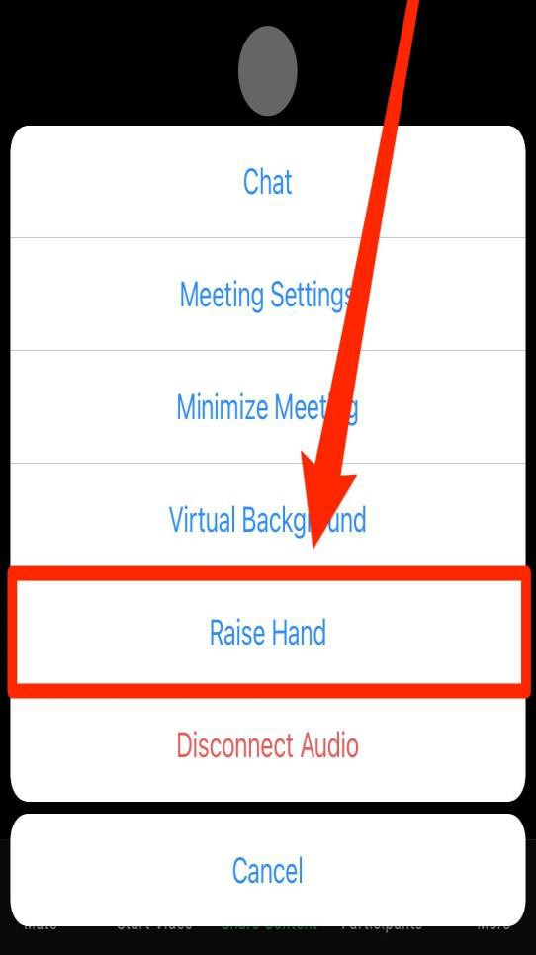

To send a message to ‘everyone’ or to individuals

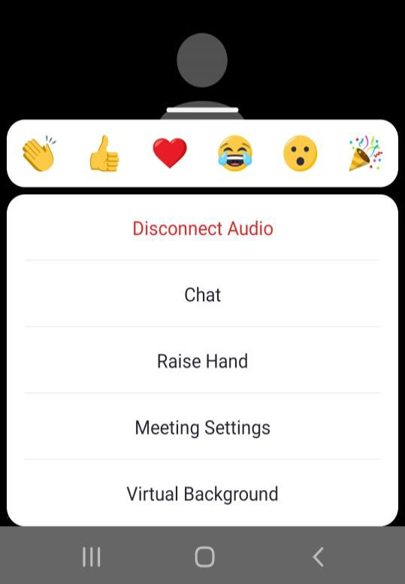Using Zoom on a Tablet/Smartphone
To ‘chat’, raise your hand or
‘react’, click on ‘more’
To turn on/off microphone/video

Objectives

- Share our stories of the benefits of bird-watching
- Learn how to recognise some of our most common birds
- Practice some bird-watching/bird-listening in your breaks
- Build awareness of how bird-watching can be good for your wellbeing
- Learn some interesting facts about birds
- At least one of you to become a twitcher!

www.mpft.nhs.uk
www.mpft.nhs.uk Together we are making life better for our communities @mpftnhs
Together we are making life better for our communities
@mpftnhs

Introductions
‘Un-mike’ or in the chat box – let us know:
What can you see right now?
  - Are you in a spot where you can see a lot of birds?
  - Or can you hear them?
  - Are you indoors or outdoors?

  - What do you find appealing about birds?
  - How does it make you feel?

www.mpft.nhs.uk
www.mpft.nhs.uk Together we are making life better for our communities @mpftnhs
Together we are making life better for our communities
@mpftnhs

Our Stories

Ring-Necked Parakeets (Seeing)
Greater Spotted Woodpecker (Hearing)
Woodpigeons – Courting Display
(Observing)

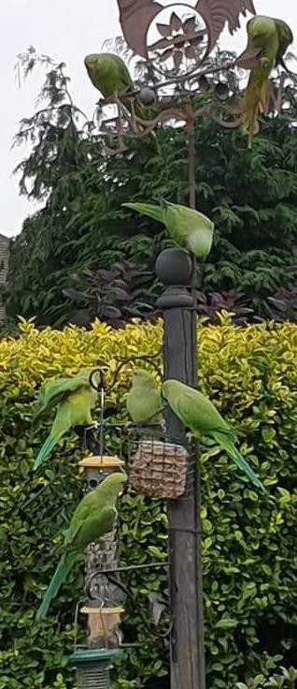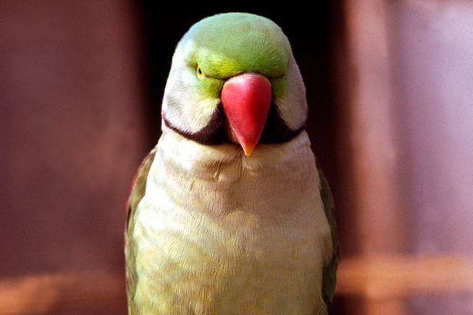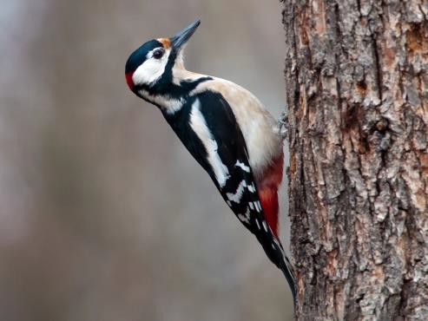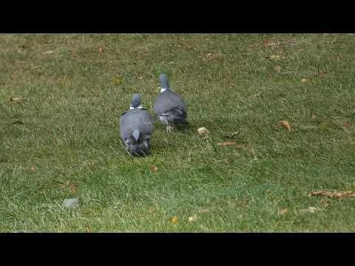www.mpft.nhs.uk
www.mpft.nhs.uk Together we are making life better for our communities @mpftnhs
Together we are making life better for our communities
@mpftnhs

Gareth’s stories

Our Stories

Nuthatch (seeing) Jackdaws (hearing) Fire Crest (Serendipity)

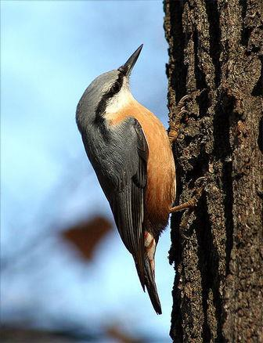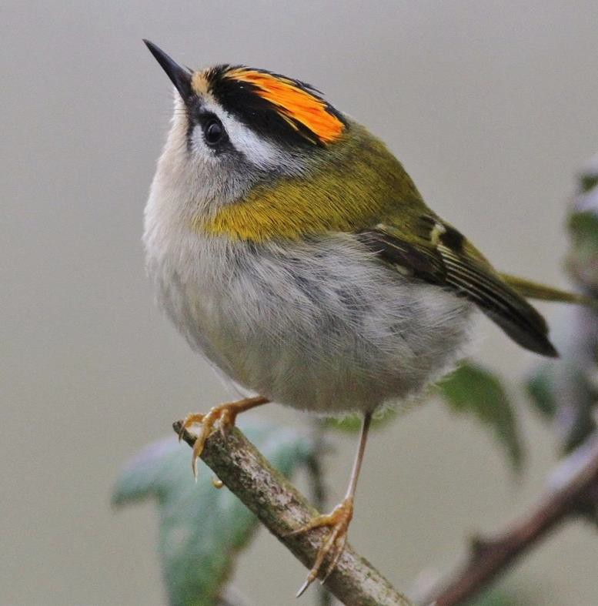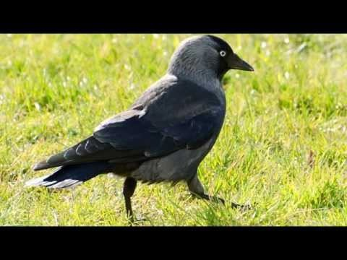www.mpft.nhs.uk
www.mpft.nhs.uk Together we are making life better for our communities @mpftnhs
Together we are making life better for our communities
@mpftnhs

Common Birds in your garden
Do you know who I am?
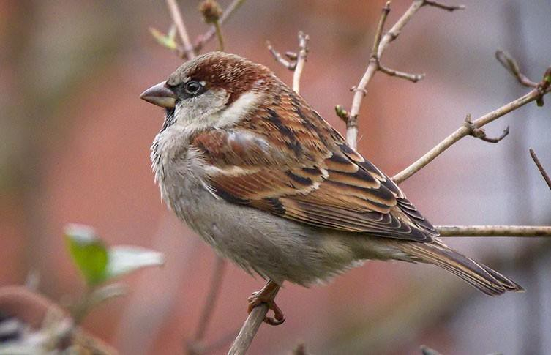
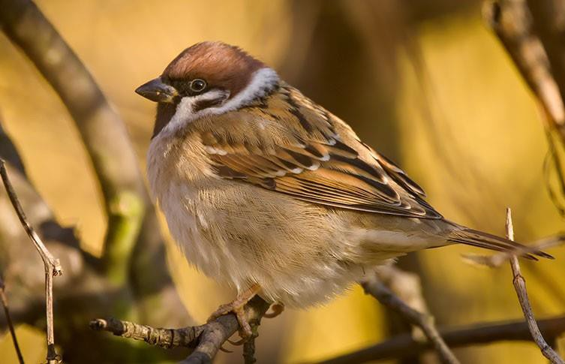

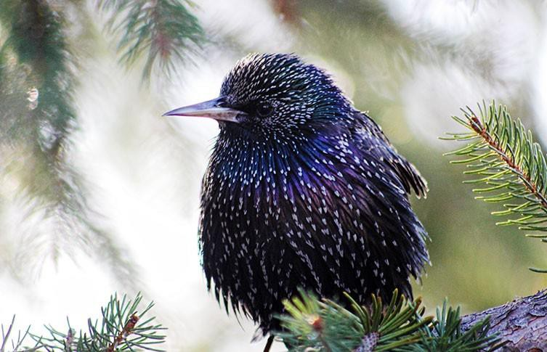

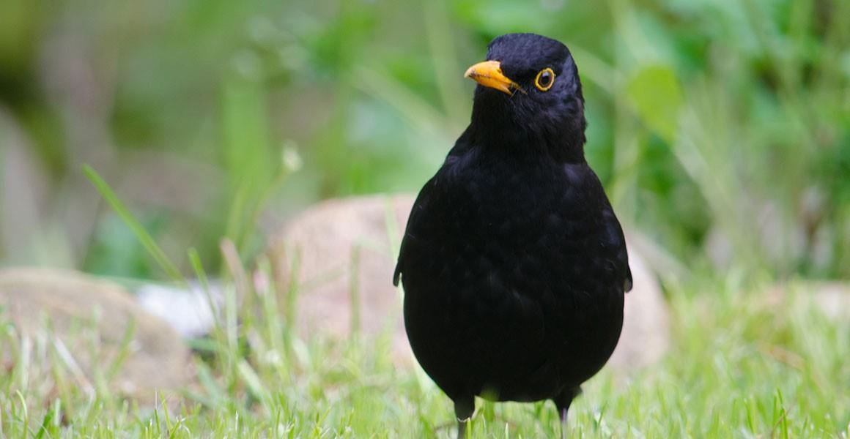

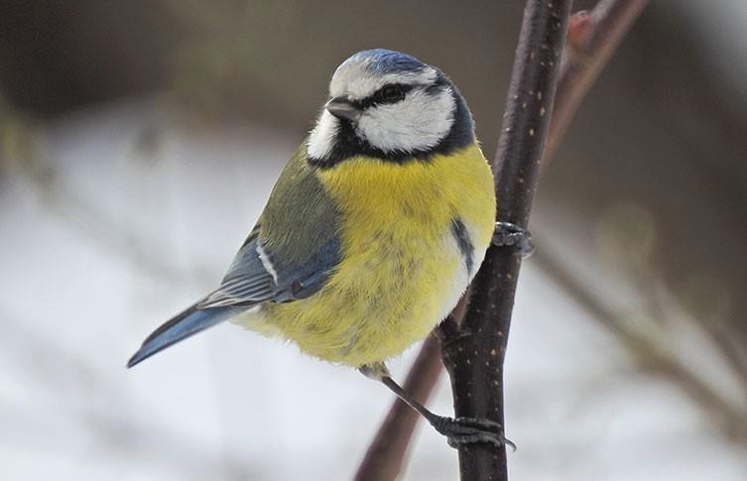

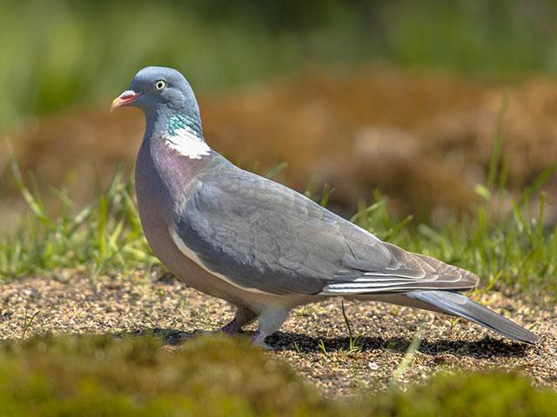

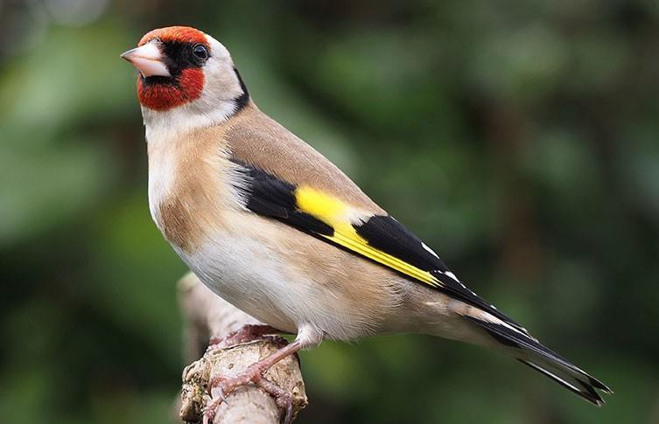

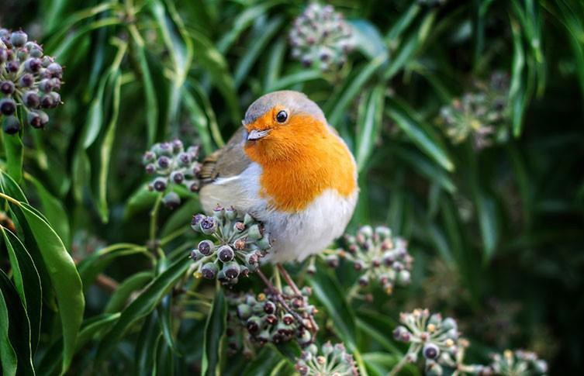

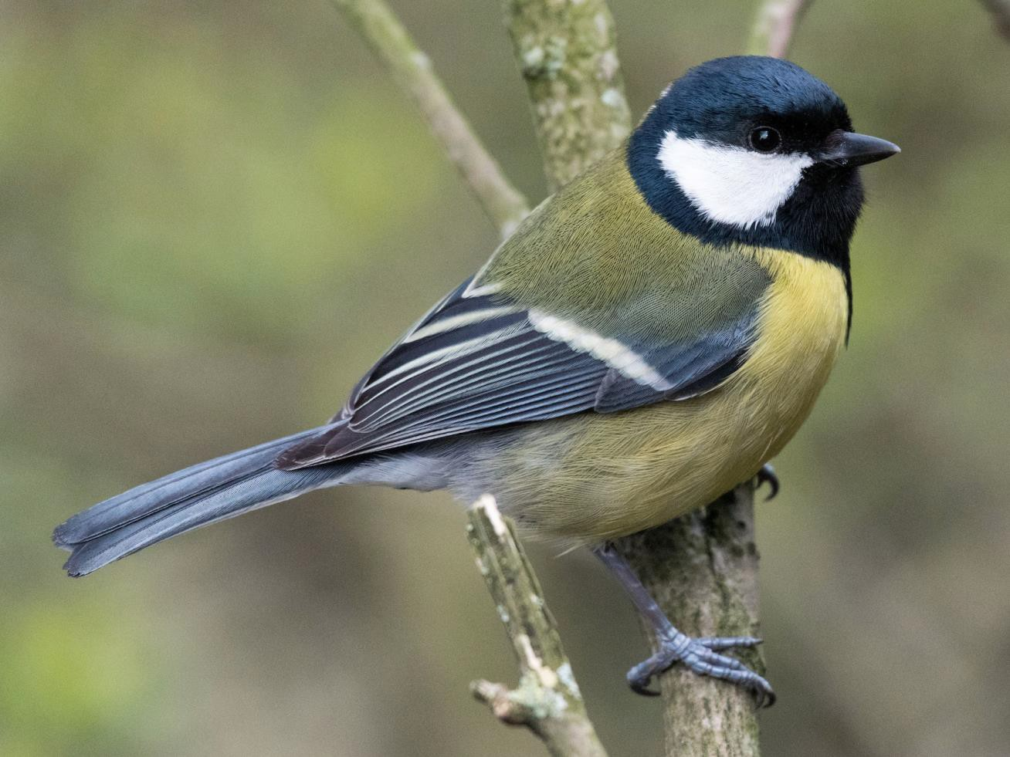

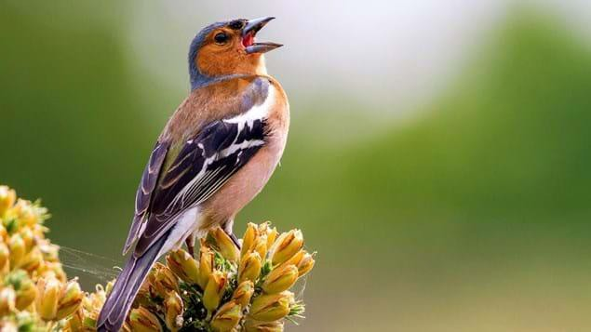

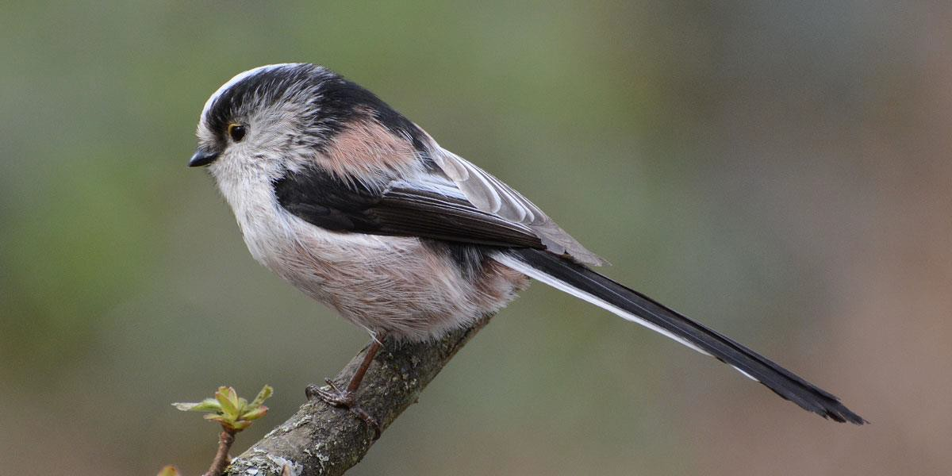

Take a Break! &
Have a look or Listen for any birds for a few minutes

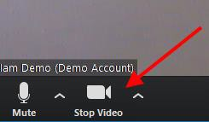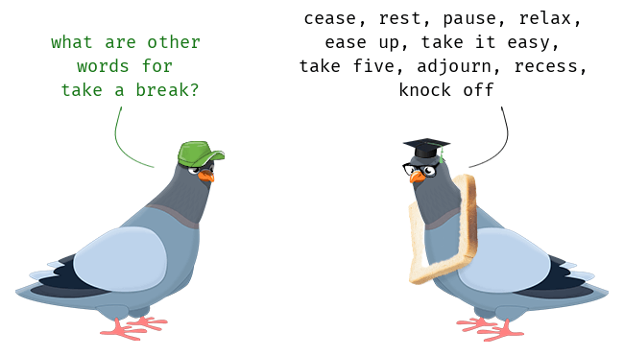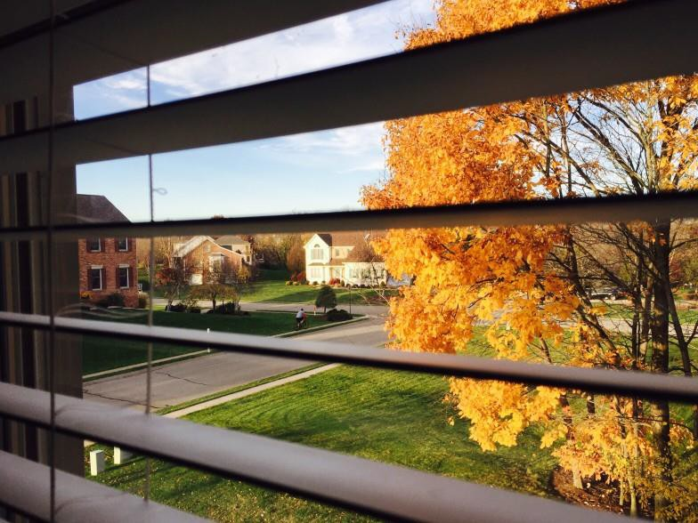www.mpft.nhs.uk
www.mpft.nhs.uk Together we are making life better for our communities @mpftnhs
Together we are making life better for our communities
@mpftnhs

Bird Bingo! – Collective Nouns for Birds

Dunnock

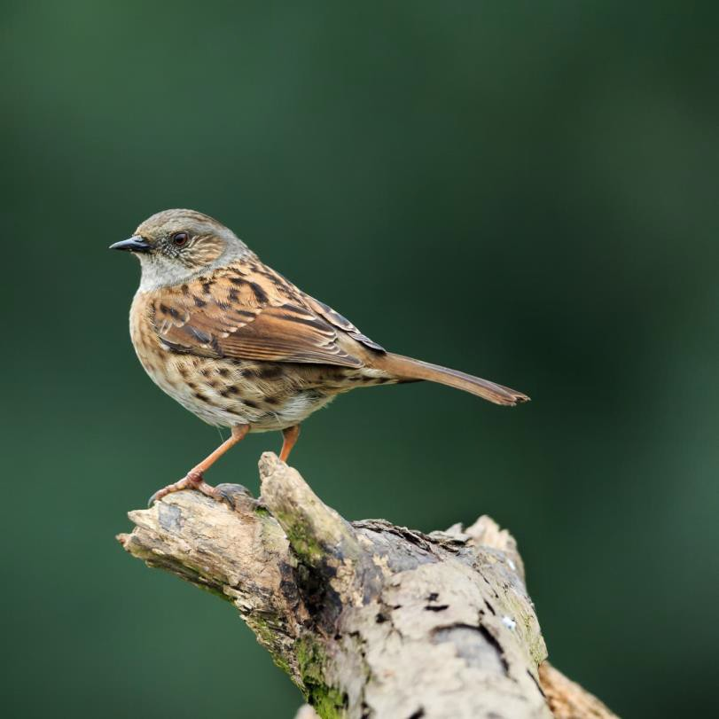
1.Confusion 2.Chattering 3.Commotion 4.Curfew 5.Jovial

Sparrows

- Conspiracy
- Swatting 3.Quarrel 4.Crown 5.Cast

Starling

1.Parliament
2.Museum 3.Quilt 4.Murmuration 5.Mischief

Blackbird

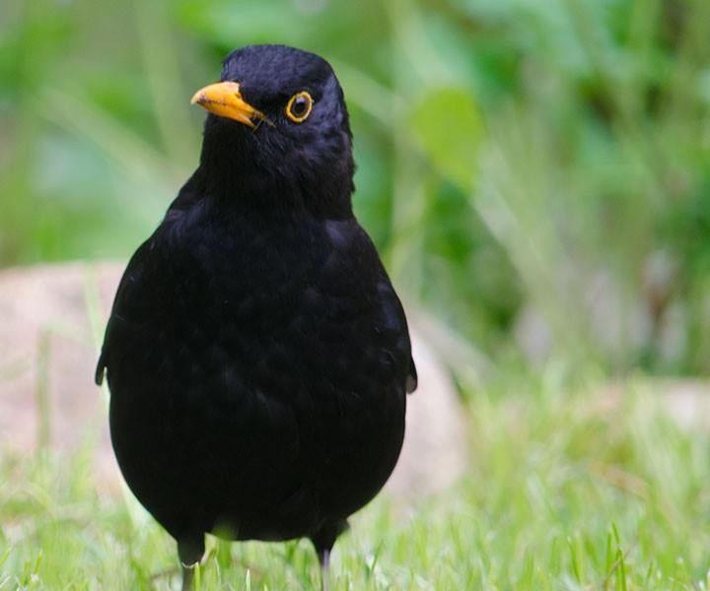
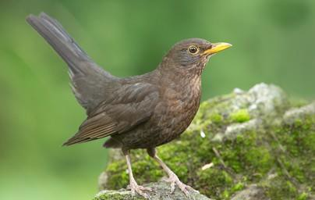
1.Cloud 2.Wisp 3.Invisibleness 4.Fall 5.Deceipt

Tits

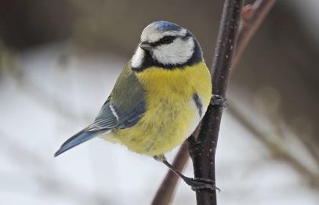
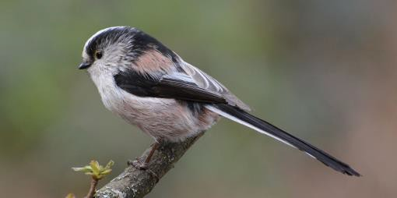
- Flock
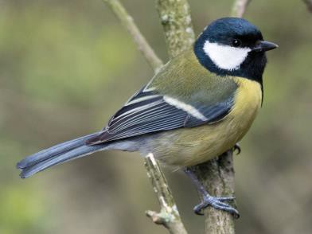
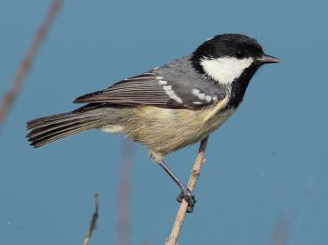
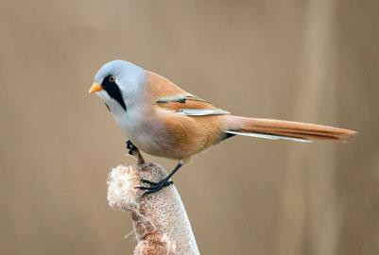
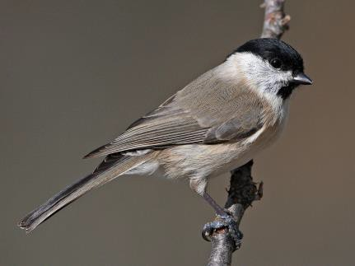
2.Merl 3.Invisibleness 4.Volery 5.Crop

Pigeons

  - Grind
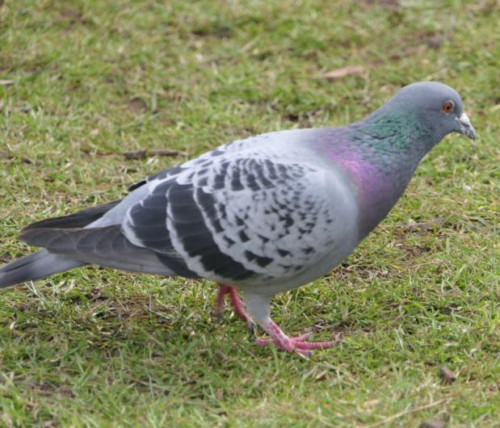
2.Loft 3.Chain 4.Bellowing 5.Herd

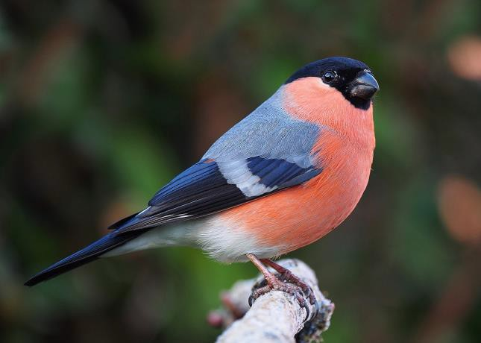
Finches

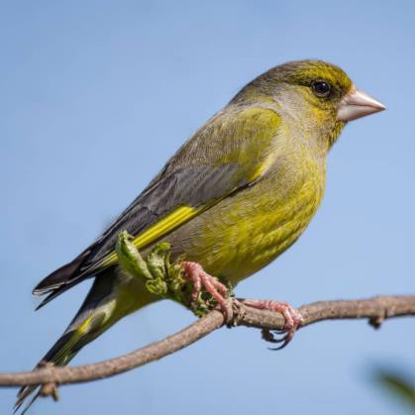
- Wedge 2.Prayer 3.Tower 4.Trembling 5.Charm

Robin

1.Blush
- Bobbin 3.Breast 4.Carol 5.Rouge

Carrion Crow

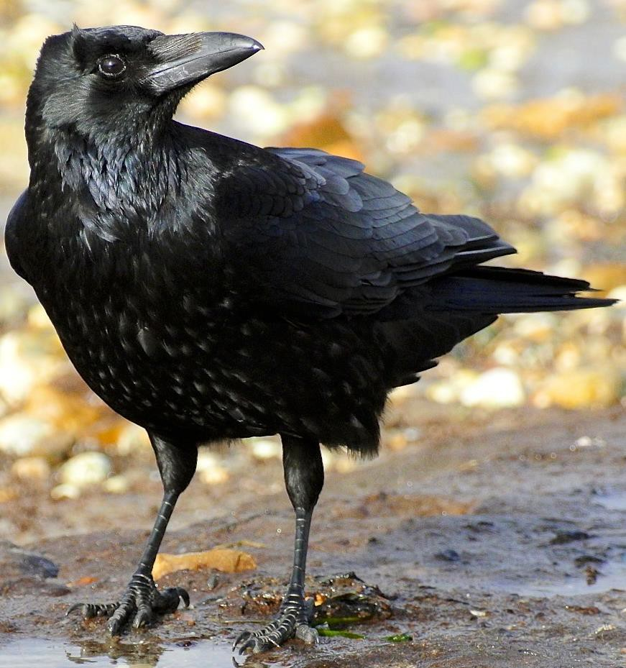
- Peep
- Flamboyance 3.Murder 4.Kettle 5.Party

10 interesting facts about birds
    - Robins will take worms out of your hands
    - Red kites hunted close to extinction in the UK – now a protected species
    - Feathers aren’t just for flight
    - Woodpeckers can peck 20 times every second
    - Ring-necked parakeets are escapees and our only naturalised parrot
    - Robins are very territorial
    - Blue tits are sneaky and intelligent
    - Waxwings prefer red berries to orange, yellow or white
    - Blackbirds love to sunbathe
    - Starlings are expert mimics

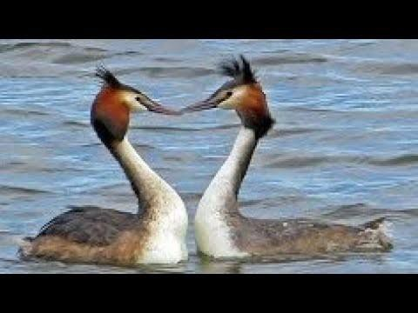
Birdwatching in Seasons
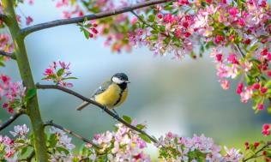
Spring - Birds suddenly seem louder and livelier from mid-January onwards – you might even spot some new faces. Birds get on with the business of breeding – look out for ‘displays’ - Great Crested Grebe Courtship Dance

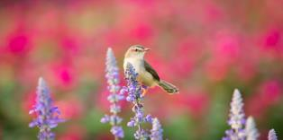
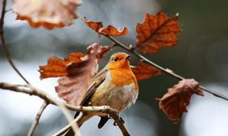
Summer – Birds will do most of their flying, singing and eating in the morning and evening when the air is cooler. During hot afternoons, they spend time resting quietly in the shade. Birds like to wade in shallow water. Provide water and bird-baths to help them out – feed high protein foods to help when moulting

Autumn – Decrease in numbers of birds in gardens – can happen quite suddenly. Why aren’t the birds hungry? attributed to sudden abundance of wilds fruits and berries elsewhere

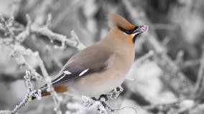
Winter – Birds often return to gardens in large numbers when the first frost occurs in autumn. Help our wild birds throughout the cold months – put out food and water on a regular basis – high fat foods to maintain fat reserves

Take a Break! &
Have a look or Listen for any birds for a few minutes…

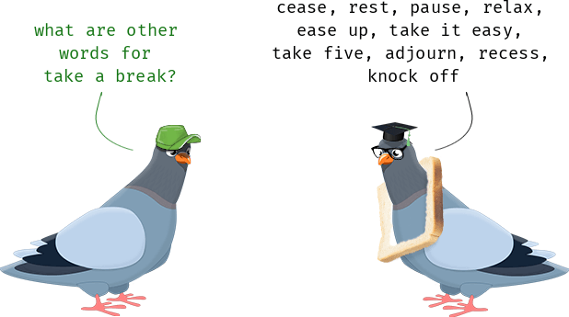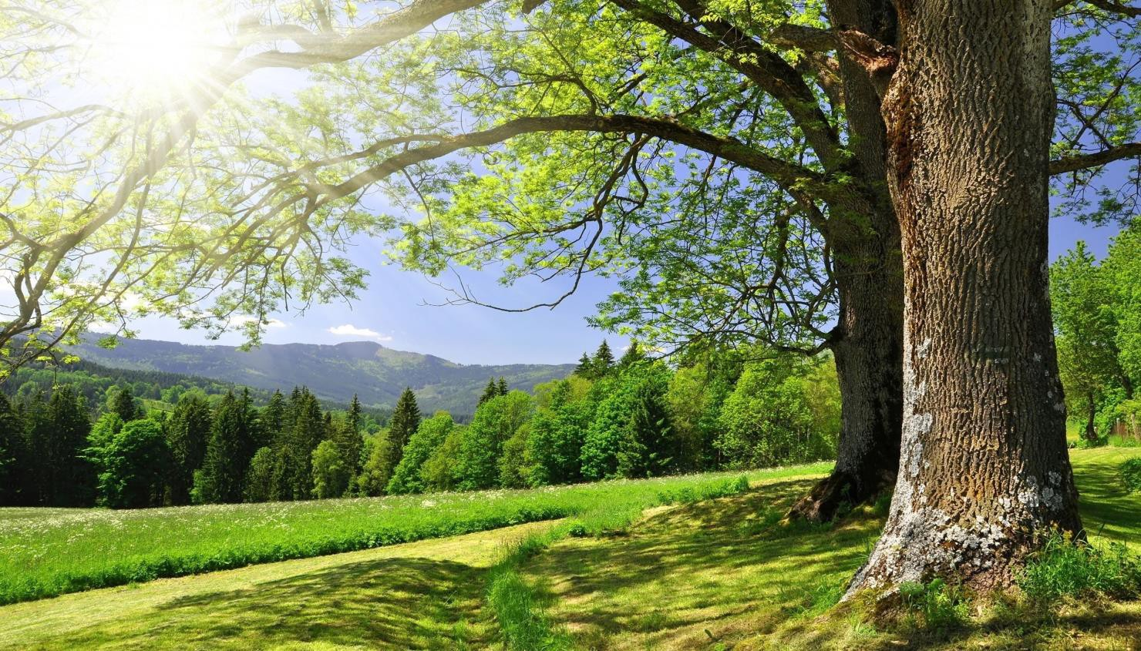www.mpft.nhs.uk
www.mpft.nhs.uk Together we are making life better for our communities @mpftnhs
Together we are making life better for our communities
@mpftnhs

Introducing the Therapeutic Benefits….

“When life becomes heavy and worries pull me down like gravity, I simply look up and suddenly there, in the weightless free air, soaring like kites, flitting from branch to branch, unencumbered, my friends the birds release my soul and I am
again free.”
Carl Schreiner, Eagle, Nebraska
    - The great outdoors!
    - Connect with family and friends
    - Time for calm
    - Keeping the mind active and healthy
    - Providing a change of scenery
    - Connecting with nature
    - Physical benefits

Birdwatching for Mental Health
    - People living in environments with more birds, shrubs and trees are significantly less exposed to feelings of depression, anxiety and stress
(University of Exeter, British Trust for Ornithology and University of Queensland)
    - People felt much happier spying birds in the afternoon, despite numbers being lower than in the morning
    - Even though most of the birds were common species such as blackbirds, crows, and blue tits, the mental health benefits remained. This means it is the number of birds an individual can see that affects mood, not species

Satisfaction and Reward

Dopamine –
birds specifically bring people a calming effect of dopamine. Being out in nature with the birds allows the prefrontal cortex in the brain to rest.

Achieving a goal – finding out what that mystery bird is that you can see or hear!
Having a goal to find out something new, and then achieving that, will stimulate the reward centres in your brain
producing dopamine that can give you a boost and reduce stress.

& There's always a new bird to look out for. One that you know about, and have never seen as yet. And if you don’t spot it, maybe you’ll discover something unexpected along the way…

So there’s several different ways Birdwatching can be rewarding, and you’ll be getting the natural health benefits of that Dopamine hit!

www.mpft.nhs.uk
www.mpft.nhs.uk Together we are making life better for our communities @mpftnhs

Together we are making life better for our communities
@mpftnhs

Natural Surroundings/Environments

    - Chemicals released by various types of plant life, in environments where birds can be found, have been shown to naturally reduce our levels of the stress hormone Cortisol.
    - getting out in nature for as little as 20 mins, stimulates our endorphins and makes us feel more alive, energetic and well. Nature helps us stay out of ruminating negative thoughts which helps depression and increases serotonin and allows our brains to recharge.
    - Birdwatching can be a great motivation to get out into these
environments. But even if you don’t spot any, you’ll still be getting the benefits of being there.

How Birdwatching Helps you Feel Interconnectedness

    - Oxytocin is the hormone that is released due to feeling that you belong, and are connected to others.
    - It’s a great health benefit, helping you to relax, and boosting your immune system.

Birdwatching can help you to feel :

    - A connection to others who are like minded
and
    - A wider connection to the whole natural world

‘Birdwatching’ with your eyes closed
    - So how do we still get some of these benefits when we cant SEE any birds….?

    - Well, maybe we can still hear them…
    - Best Time of Year for Birdsong – Spring
    - Best Time of Day – the Early Bird Catches the Worm!

    - ‘Birdwatching with your eyes closed’ is the name of a book and a podcast by SIMON BARNES

The Present Moment
    - Listening to birdsong can help you centre yourself and be more in the moment.

    - This can be a great antidote to Anxiety and Stress.

    - Try focussing on your breathing to link your mind and body and then open your awareness to whatever birdsong you can hear in your area.

    - We’re tapping into Mindfulness Practice here and you can do that with your eyes open too…

Lets give it a go….
    - 4K Deep Forest - 8 Hours NO LOOP Birdsong - Robin & Blackbird Singing - Relaxing Nature Ambiance –
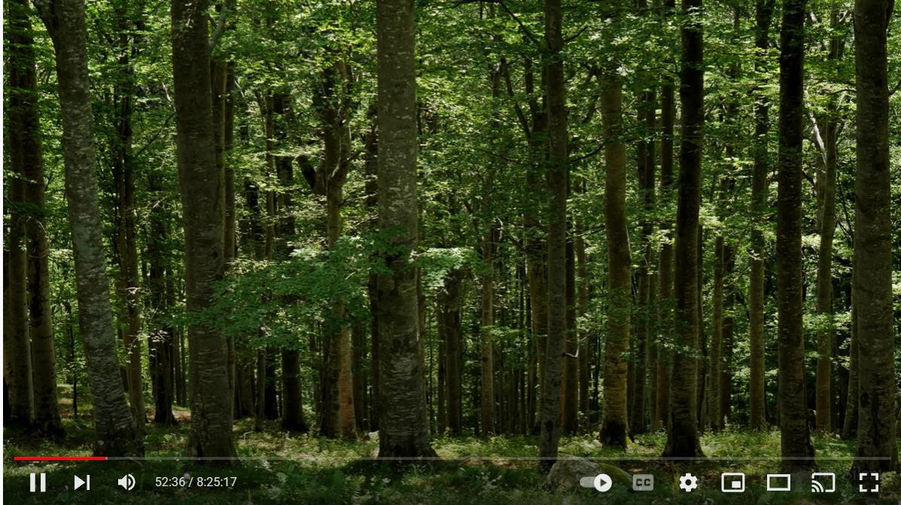
YouTube

Take a Break! &
Have a look or Listen for any birds for a few minutes…

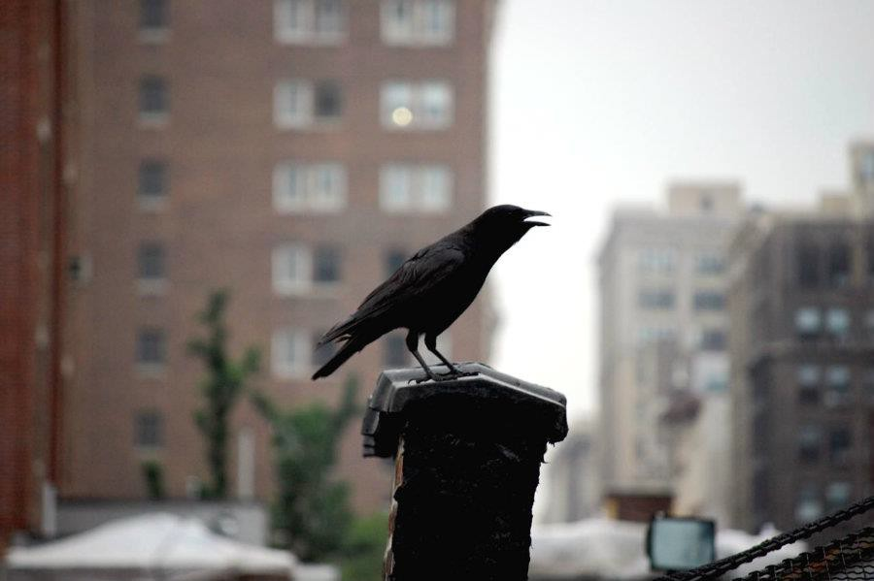www.mpft.nhs.uk
www.mpft.nhs.uk Together we are making life better for our communities @mpftnhs
Together we are making life better for our communities
@mpftnhs

www.mpft.nhs.uk
Together we are making life better for our communities
@mpftnhs

How to Get Started – Give Birding a Go!
- Start in your garden (or local park) – find a quiet spot and stay very still. You’ll be amazed at what you can see and hear even in 10-15 minutes – or just look out of your window!
- Access live feeder cams
- Learn more about the birds – RSPB Bird Identifier - RSPB Bird Identifier
- Keep a list of what you see - when you see something different, it’s more exciting to find the more scarce ones
- Take it to the next level – join the ‘Big Garden Birdwatch’ run by the RSPB

Steps for the Future

If you find that you’re suffering from a mental health condition such as stress, anxiety, or depression, while it’s not recommended you cut out or stop taking any medication or treatments you’re currently using, it may be a good idea to get outside to see what kind of birds you can see.

Whether you’re simply investing in a bird feeder and setting it up in your back garden or you’re going for a walk in nature to see what you can see, the act is beneficial to your mind and body, even if you don’t see something.

You can do this in a nearby rural area or even in your local park or wildlife reserve. Once you become mindful of these
natural areas, you’ll soon realise that birds and wildlife are present throughout society, even in built-up areas.

All you need to do is become mindful and watchful for their existence, and already you’ll start to see the benefits. Birdwatching is renowned for being a meditative exercise and can help nurture your connection with nature.
Instead of allowing your mind to run free on unhelpful thoughts or ruminating, which usually result in anxious or stressed out thoughts, allowing yourself to focus on something like looking for birds can help keep your mind present and those pesky thoughts at bay.

Of course, this is a practice that takes time to develop and nurture, but with regular practice and focus, you’ll be there in no time at all.

www.mpft.nhs.uk
www.mpft.nhs.uk Together we are making life better for our communities @mpftnhs
Together we are making life better for our communities
@mpftnhs

Our favourite programmes!
BBC Spring/Summer/Autumn/Winterwatch

BBC Winterwatch Previous Episodes

David Attenborough – The Wonder of Song

BBC iPlayer David Attenborough Wonder of Song

Attenborough’s Paradise Birds

BBC Two iPlayer Paradise Birds

A Guide to Mountain and Moorland Birds -
Shropshire

BBC iPlayer Mountain and Moorland Birds

British Trust for Ornithology

Some Useful Websites
RSPB Bird Identifier

https://www.bto.org

Wildlife Trust

https://www.wildlifetrusts.org/wildlife-explorer/birds

Royal Society for the Protection of Birds (RSPB)

https://www.rspb.org.uk/

Natural History Museum – British Birds

Natural History Museum - British Birds

Collective Terms for Birds

Collective Terms for British Birds
Bird Identifier

Identify Birds by Song - Countryfile

Bird Song Identifier

RSPB Hungry Birds Game!

Hungry Birds Game for Kids

BBC Spring/Summer/Autumn/Winter Watch

BBC Springwatch

Wildlife Trust

How to Identify Common Garden Birds

Live Bird Cams

https://www.birdfood.co.uk/webcams

https://www.birdsofpooleharbour.co.uk/osprey/osprey-webcams/

https://youtu.be/xtT2zlB-iHc - Red Kites Feeding in Wales

https://birdwatchinghq.com/live-bird-cams/ - Twitch all over the World!

https://www.facebook.com/watch/live/?ref=watch_permalink&v=3828331907392 503 – BBC Springwatch Live Cams

www.mpft.nhs.uk
www.mpft.nhs.uk Together we are making life better for our communities @mpftnhs

Together we are making life better for our communities
@mpftnhs

Wild Geese, by Mary Oliver
You do not have to be good.
You do not have to walk on your knees
for a hundred miles through the desert repenting. You only have to let the soft animal of your body love what it loves.
Tell me about despair, yours, and I will tell you mine.
Meanwhile the world goes on.
Meanwhile the sun and the clear pebbles of the rain are moving across the landscapes,
over the prairies and the deep trees, the mountains and the rivers.
Meanwhile the wild geese, high in the clean blue air, are heading home again.
Whoever you are, no matter how lonely, the world offers itself to your imagination,
calls to you like the wild geese, harsh and exciting - over and over announcing your place
in the family of things

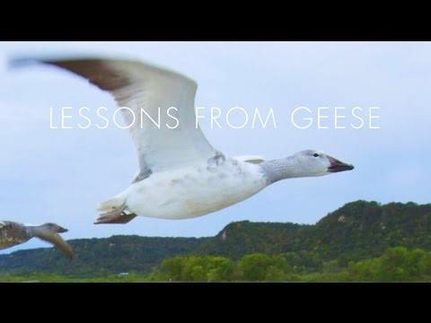
Lessons from Geese

Lessons from Geese: Line of One

