Memory Tips and Resources

When someone has memory difficulties, memory aids can be useful. Certain ways of organising things may also help to jog the memory and reduce any forgetfulness, confusion and disorientation.

Memory aids
- Large calendar – to plan events and tick off the days as they pass.
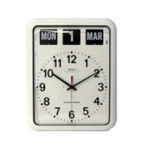
- Large diary – to record events that have happened, e.g. visits, appointments.
- Keep a message book by the phone to record any important phone messages.
- Noticeboard/ white board – for reminders.
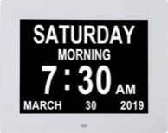
- Large clock –placed in prominent position, some find analogue displays easier to read than digital.
- Day/ date clock – to help with orientation - some clocks also allow you to set reminders such as putting bins out, taking medication.
- Lists – tick them off as you complete them.
- Use mobile phone or smart speaker (e.g. Alexa) to set reminders.
- Visual prompts – e.g. leave your shopping list by your house keys.
- Keep a list of key numbers/ emergency contacts by the phone – add a photo of the person if that helps.
- If you struggle to find items, it may be helpful to label cupboards/ draws and list what goes where, add photos if this helps.
- Room signs with photos help some people to find their way around the home.

Memory Tips
- Sticking to a familiar daily routine can help to keep us organised and orientated.
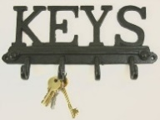
- De-clutter and organise your belongings – this helps to reduce distractions too.
- Keeping things in the same place so they can always be found e.g. keys on hook.
- Talk yourself through a task or write down the main steps to prompt you.
- Use recipe cards with photos to support cooking tasks.
- Set things out in the order they have to be done, e.g. order of clothing for getting dressed, or items required for an activity.
- Break down activities into smaller achievable steps.
- If words are hard to find at times, make a photo book with key words/ phrases and associated photos. This can be helpful with names and faces too.

Mental Stimulation to help preserve cognitive functioning
- Listening to the news/ reading newspapers
- Listening to music/ radio and audiobooks
- Doing crosswords/ word searches
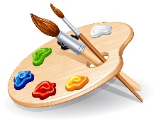
- Sudoku/ number games
- Card games
- Art / Craft work
- Learning new skills
- Reminiscence
- Quizzes
- Watching documentaries
- Reading books/ short stories/ magazines
- Looking through photographs/ keepsakes

Maintaining skills/ functioning
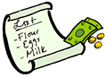
- Tending to personal care
- Housework
- Preparation of food/ meals
- Shopping trips
- Using money
- Gardening
- Regular exercise
- Engaging in hobbies
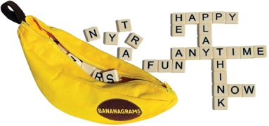
Stimulating Language
- Word games e.g. Scrabble, Bananagrams, Dobble
- Taking part in discussions about current affairs
- Online groups and classes e.g. U3A, Future Learn
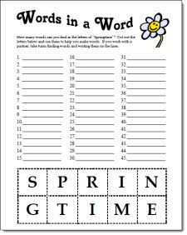
- Reading/ Audiobooks
- Social interactions - talk to people in group situations as well as one to one, use the telephone to keep in touch if face to face visits aren’t possible
- Word association puzzles e.g. Laurel and ……………
- Chatting about past events, use photos/ keepsakes to prompt memory
- Pick a subject then go through each letter of the alphabet naming relating items e.g. flowers, cars, film stars
- Making as many words as you can from a long word

Healthy Lifestyle Choices – these help to reduce risk factors associated with dementia
- Keep fit and maintain a healthy weight
- Take a healthy balanced diet, try to avoid fried and processed foods, and keep well hydrated
- Keep any long-term conditions well managed e.g. high blood pressure, diabetes, thyroid problems.
- Attend regular check ups with your GP and if you have any concerns about your health seek advice early.
- Review any long-term medication regularly with your GP.
- Limit any alcohol intake and stop/ cut down smoking if possible.

Activity resources
- www.activitiestoshare.co.uk - Activity resources
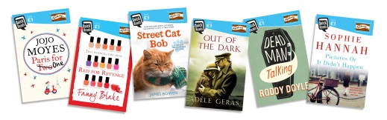
- ‘Quick Reads’ books have shorter chapters/ stories to make reading easier, these are available from the library.

Puzzles
- https://freerice.com/categories/
- https://crayonsandcravings.com/printable-word-searches/
- http://www.fun-with-words.com/rebus_puzzles_09.html
- https://freedailycrosswords.com/

Creative resources
- http://festival.ageofcreativity.co.uk/downloads/ for creative/ arts information and ideas e.g. virtual tours of Museums & Galleries, online dance and music workshops
- https://www.justcolor.net/art/coloring-art/ for free colouring templates to download and print

Keeping active
- https://www.shropshireccg.nhs.uk/news/new-physical-activity-booklet-for-older-adults/
- https://britishgymnasticsfoundation.org/lovetomove/

