Products Available to Reduce the Risk of Wandering or Becoming Lost
Information in this document includes GPS tracking devices, door sensors, movement sensors, memo minders and having emergency contact details.
Please be advised that the links included are just examples of options available, there are many alternative products at differing prices on the internet.

Assistive technology:
- GPS Tracking Devices
A GPS tracking device can provide added safety and independence, as well as reassurance that your loved one can be located. GPS trackers can be carried in pockets, in bags, on belt loops, on keyrings, magnetically pinned to clothing and even within shoe soles.
Examples of Websites:
Tracker Shop: https://www.trackershop-uk.com/product-category/personal-gps-trackers/dementia/
Tech Silver: https://www.techsilver.co.uk/best-gps-tracker-buying-guide/
Easy Link: https://www.easylinkuk.co.uk/product-gps-location-trackers
Amazon: https://www.amazon.co.uk/s?k=gps+tracker+for+dementia+and+elderly+care&crid=3UHM87M2WDN5S&sprefix=GPS+Tracker+for+Dementia%2Celectronics%2C163&ref=nb_sb_ss_fb_1_24_ts-doa-p

- Door Sensors
Mini Chime: This makes an alarm/chime sound when the door is opened which can alert you when the door is opened.
Website link: https://www.amazon.co.uk/Defender-Magnetic-Alarm-Accessory-Windows/dp/B01JJ6C7W4
Telecare Door contacts: Placed above a front/back door; the door usage sensor can detect if you or someone else leaves the property and doesn’t return within a certain period of time, and will raise an alarm to either the carer or the monitoring centre.
https://www.welbeing.org.uk/what-is-telecare/door-usage-sensor/
http://www.housingcare.org/service/ser-info-7670-firstcall-247.aspx
HIVE: Hive Door sensors can notify you via your mobile device – requires WIFI.
https://www.argos.co.uk/search/door-sensor/
https://www.currys.co.uk/gbuk/smart-tech/smart-tech/smart-home/smart-monitoring/hive-window-or-door-sensor-10167410-pdt.html

- Movement sensing alarms
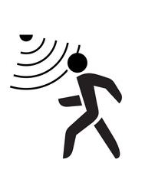
https://www.easylinkuk.co.uk/index.php?route=product/search&search=movement%20sensor
- Activity Monitoring systems:
Just Checking System: To monitor motion and activity throughout the house including door usage, this can notify you via your mobile device or email (does not require WIFI).
https://justchecking.co.uk/
Canary System: To monitor motion and activity throughout the house including door usage, this can notify you via your mobile device or email (does not require WIFI).
https://www.canarycare.co.uk/
If deemed suitable, an OT within the memory service can loan either the Just checking or Canary system for a period of 2 weeks to gather information and act as a trail if you are considering to purchase one.

- Digital clock
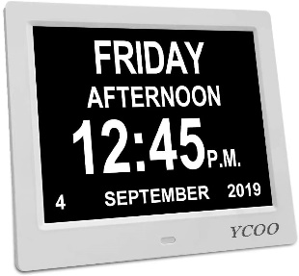
A digital clock to show the date, time and day of the week display to help those who might find time orientation a challenge.
AlzProducts.co.uk: https://www.alzproducts.co.uk/7-dual-display-2-in-1-calendar--day-clock
Amazon: (search ‘digital clock’ or ‘dementia clock’) https://www.amazon.co.uk/s?k=memory+clock&ref=nb_sb_noss

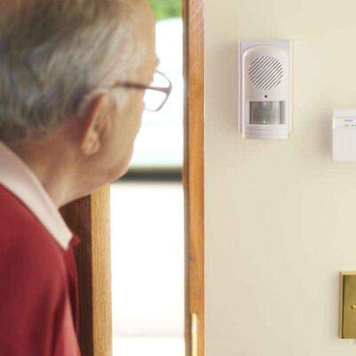
- Memo Minder
Record your own message and when the PIR motion sensor detects movement your message will be played. High-quality audio recording up to 20 seconds in length. Message can be rerecorded, allowing for new messages and reminders to be played. Detection range of 5m and a 30° angle.
A popular example is to leave a reassuring message warning a loved one not to leave the house if it is dark, or to remember their keys, wallet, and phone if they are leaving the house.
If deemed suitable, an OT within the memory service can provide a memo minder.

- Assistive Technology Funding:
If you wish to access funding for any of the above suggested assistive technologies, it may be available via the ‘carers hub’ on 0330 123 1937, www.thecarershub.co.uk or Email info@thecarershub.co.uk. As it is the ‘carers hub’ you will have to register with them and then ask for access to the assistive technology fund.

Identity information
- Herbert Protocol
The Herbert Protocol is a national scheme that encourages those living with dementia, or those caring for them, to compile useful information that could be used in the event that they go missing.
Once the pack of information is complete, the carer keeps it in a safe place, ready to hand to the police when needed. Having it readily available can reduce the amount of time it takes to find the person and return them to safety.
A completed Herbert Protocol information pack includes:
- Vitals – name, current address, telephone number(s)
- A physical description of the person, including an accurate, up-to-date photograph
- Medical history, including their dementia diagnosis
- Life history – previous job roles, hobbies, likely places they may visit
- Carer and family information
- Missing now – when and where they were last seen, what they were wearing
Link to form: https://www.staffordshire.police.uk/SysSiteAssets/media/downloads/central/advice/herbert-protocol/herbert-protocol-form.pdf

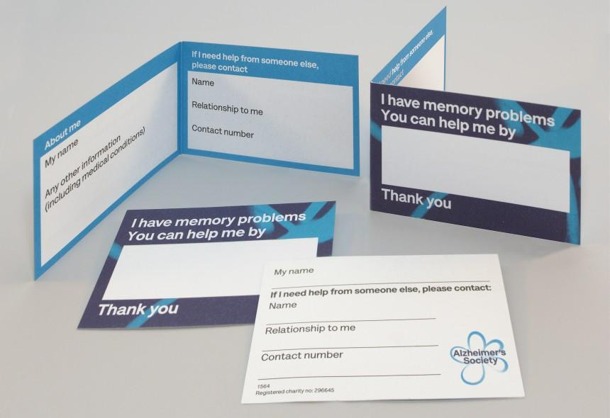
- Get free Helpcards via the Alzheimer’s society
Helpcards are for people with memory problems and dementia to carry with them. Using a Helpcard can make it easier to get help or assistance when out in the community. Helpcards are the size of a credit card and are free to order.
Link to Website: https://www.alzheimers.org.uk/get-support/publications-and-factsheets/helpcards

- Engraved Bracelets:
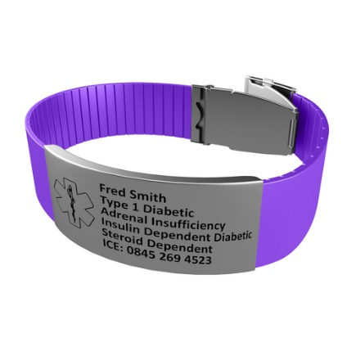
Bracelets can be engraved with emergency contact details.
Etsy: https://www.etsy.com/uk/market/dementia_id_bracelet
https://www.theidbandco.com/Silicone-Bracelet-with-Engraveable-Tag-5190?CountryCode=UK&gclid=EAIaIQobChMItd3X-Jnt4AIVFflRCh1pNQqXEAkYAiABEgLrJvD_BwE&CountryCode=UK&gclid=EAIaIQobChMItd3X-Jnt4AIVFflRCh1pNQqXEAkYAiABEgLrJvD_BwE

- Guardian Angel Devices:
When a smartphone is held over A guardian angel badge, wristband, bag-tag or keyring the persons first name and an emergency contact number will be displayed.*please switch on NFC on your phone. http://dementiabuddy.co.uk/guardian-angel-buy.php

