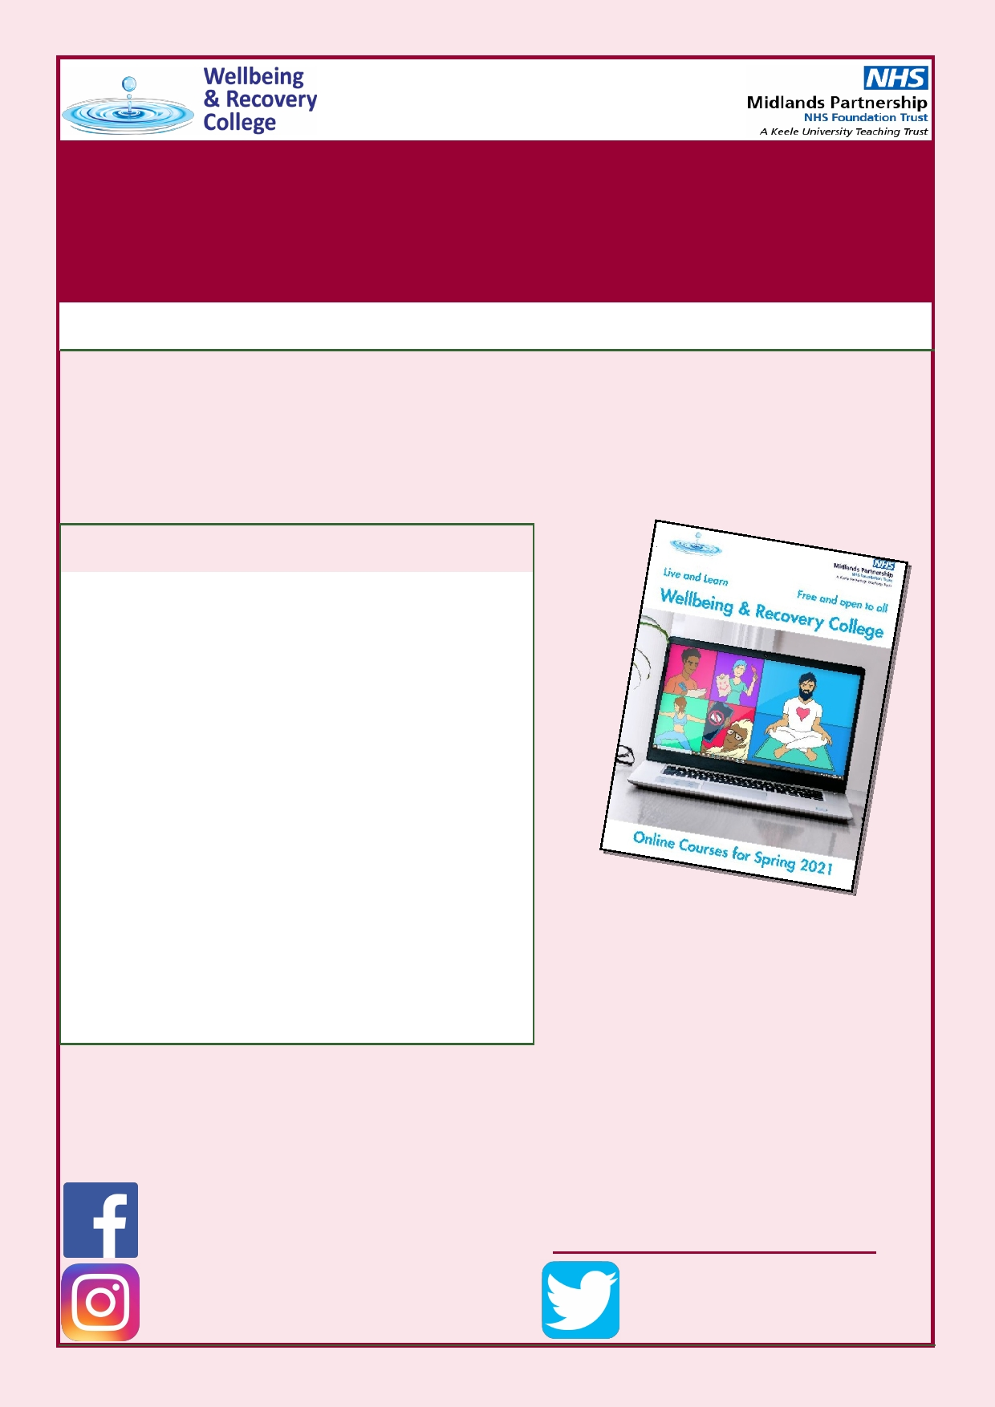INSPIRE
AUTUMN 2020 ISSUE 4
Welcome to Issue 4 of INSPIRE, a termly newsletter for the
Wellbeing and Recovery College. Here we will keep you up to date with what is happening at the college, including details about our courses, stories from members of the college team, pictures of what our students have been up to recently, and other information that we think you'll find useful.
INSIDE THIS ISSUE:

An Update From The College
Coming Up In The Spring Term
Learn how to use Zoom
Online Social Events Hygge and Wellbeing
Self-Compassion
Tips for Staying Well in Winter
Welcoming Naima and Beth
Anne-Marie's Story
What have our students been up to?
Thank You
About Us & Contact Details

PG 2

PG 2

PG 3

PG 3

PG 4

PG 4-5

PG 6

PG 7

PG 7

PG 8-9

PG 10

PG 10

We are pleased to be able to
deliver a wide range of courses online via Zoom again in the Spring Term. For further details about this, please see Page 2.

Are you following us?
Find us on social media to stay up to date on
the availability of our courses and much more!

Wellbeing and Recovery
College MPFT

@wellbeingrecoverycollegempft
Website:
https://recovery.mpft.nhs.uk/

@reccollegempft

Page 2 INSPIRE
An Update From The College
We hope that you have all been able to stay safe and well this year.
It's been lovely seeing so many of you online over the last term and we look forward to seeing you online again in the New Year. We will keep doing everything we can to offer as much as possible for you to engage with. The guidance and advice on safety is changing all of the time, so we'll be constantly reviewing everything and keeping you updated with our offering
throughout the Spring Term.
In the meantime, we really hope you enjoy the large selection of online
courses that we will be running for you in the New Year.
Coming Up In The Spring Term
Behind the scenes, we've been working hard to prepare our Spring courses. We
have 20 different courses available, many of which are running several times
throughout the term. We have produced some brand new courses for you and
have reformed some of our old ones so that they can be taught online for the first
time. Our upcoming courses can be found here in our Spring prospectus:
https://flip.printstafford.com/wrc-spring21/
We're pleased that the following courses are making a return to our prospectus:
• Lived Experience and the Potential it Holds—This course is designed for those who
would like to explore how Lived Experience of Mental Health difficulties can be used, and the impact it can have on mental health services and society as a whole.
• Open arted, Open hearted— This course is brought to you by two enthusiastic art
fans. You will produce projects using mixed media which will focus on specific
themes. Our sessions provide a relaxed environment to meet like-minded people
who enjoy art.
We also have some brand new courses available for you to try out, these are:
• Bird watching for Wellbeing—Wild birds are beautiful and Bird-watching can have a
positive impact on mental and physical wellbeing. Bird watching can be enjoyed both
outdoors and from the comfort of our own homes. This course will enable you to
meet like-minded people as we introduce you to the beauty of bird-watching and
how this can be used to practice mindfulness and improve our overall wellbeing.
• Rhythm of Rest: Do you find that you or the people around you always feel busy?
That we never feel rested? What even is rest? Did you know that there are 7 types?
In this session we will be looking at these types of rest and thinking about how to use
them to create our own rhythm.
Mindful Moments Weeks: In addition to all of our courses, we will be running two
'Mindful Moments weeks' next term; one for the week beginning 11th January and one
for the week beginning 15th March. During these weeks, we really want to encourage
you to incorporate some calm moments into your days. Each morning in our Mindful
Moments weeks, at 9:15am we will be facilitating a 10 minute mindful breathing
exercise and in the afternoon at 4pm we will be doing a 10 minute mindful drawing
exercise. If you would like to join in with these please get in touch! You can find more
information in our prospectus.
We will also be running online social events: see page 3 of this newsletter for details.

ISSUE 2 Page 3
Zoom Cafés—Learn How To Use Zoom
As we will be delivering all of our courses online on Zoom for the foreseeable
future, we will continue to run Zoom Cafés for you. A Zoom café is a relaxed, informal 30-minute session that will enable you to learn the basic functions of zoom so that you can feel confident about attending our online courses. You will learn how to access a zoom session from an email link, how to use
your microphone and camera, where to find the chat box, and more. Please
get in touch to book your place on one of our Zoom Cafés and then we will send you an email with an invitation. Below are the Zoom Café dates that are
coming up in December and January:
December: January:
• Mon 7th Dec at 3.30pm • Tuesday 5th Jan at 11:00am
• Tues 15th Dec at 11:00am • Wednesday 13th Jan at 1:00pm
• Thurs 17th Dec at 2:00pm • Mon 18th Jan at 3:00pm
• Thurs 28th Jan at 10:00am
Online Social Events
We understand that many of you may be feeling isolated at the moment, and
we want to help connect you with other Wellbeing and Recovery College students. For this reason we will continue to put on some Zoom-based Online
Social Events for you. We will be running the following types of events:
Quiz: Fun, family-friendly quizzes. The questions are suitable for all abilities and
will cover a range of different topics. Everyone is welcome!
Reader's Café: Bring along your favourite book, comic, magazine etc. and chat
with other bookworms about reading!
Creative Corner: A space for creative folks to talk about arts and crafts and
maybe even complete some small projects using easy-to-find materials.
The dates for the upcoming Online Social Events are:
• Quiz—Tuesday 15th December 2020 at 1:00pm
• Quiz— Wednesday 13th January 2021 at 11:00am
• Reader's Café—Thursday 28th January 2021 at 11:00am
• Quiz—Tuesday 23rd February 2021 at 2:00pm
• Creative Corner—Tuesday 9th March 2021 at 1:00pm • Quiz— Thursday 25th March 2021 at 12:00pm
You will need to book your place on these events and places will be offered
on a first come, first served basis. If all places fill up we will operate a waiting list. To find out more about these events or to book your place, please get in touch with the college using the contact details on the back page.

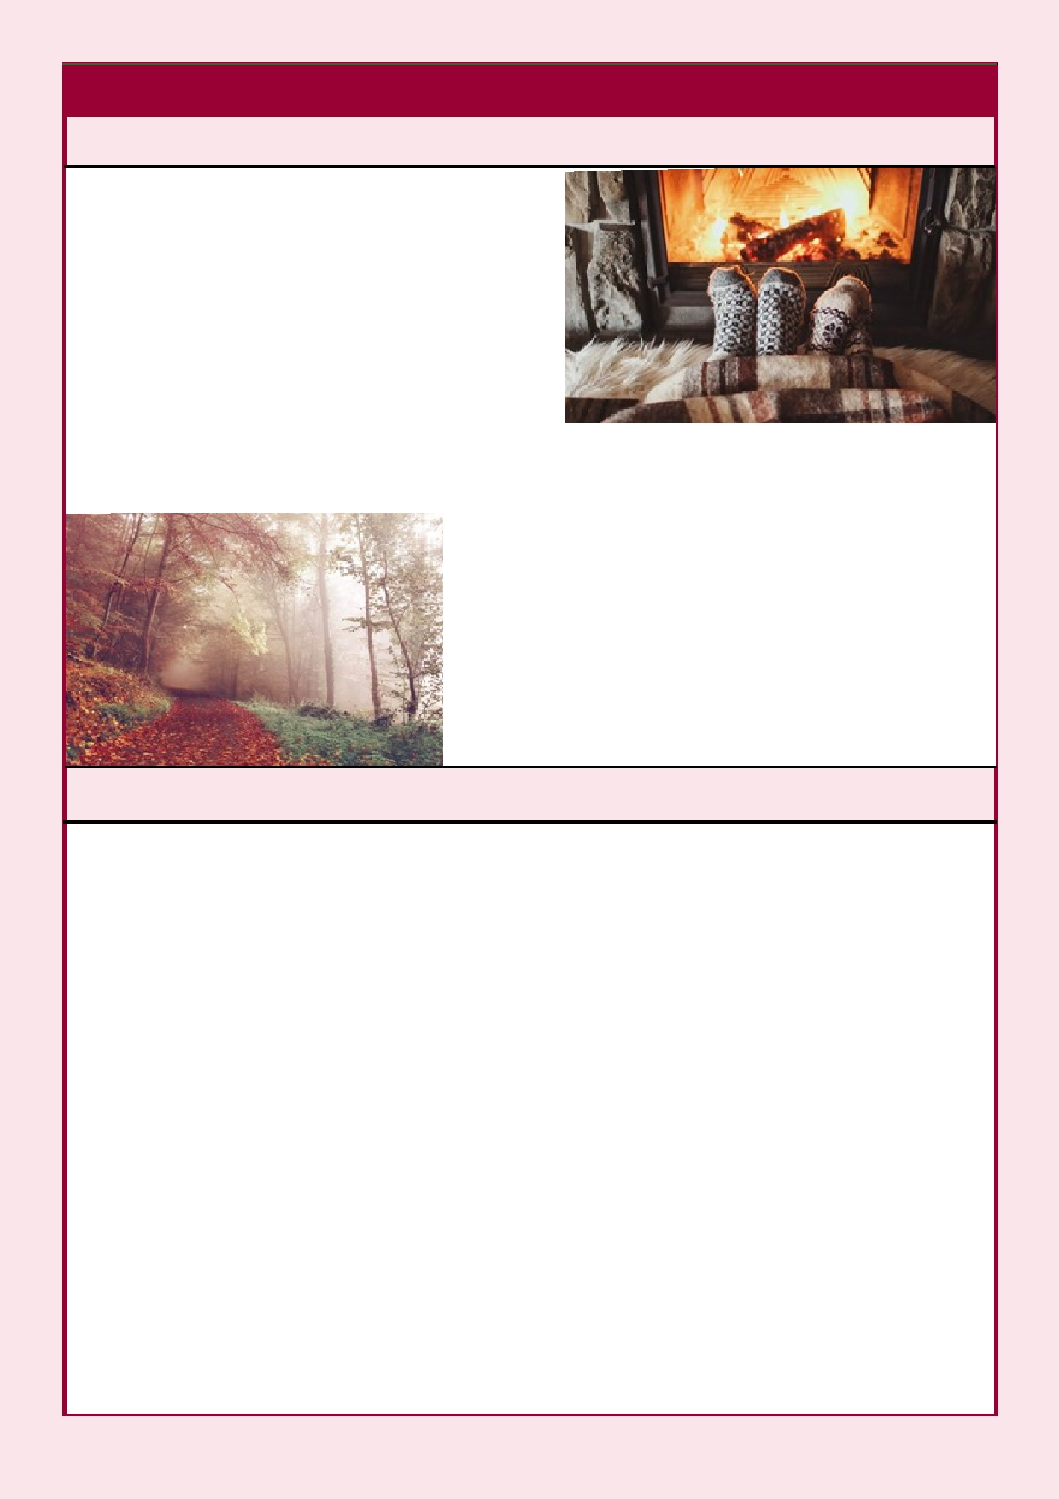Page 4
Hygge and Wellbeing
Hygge (pronounced "Hyoo—gah") is a
Danish concept that can't be translated into one single English word, but it encompasses a feeling of cosy contentment and wellbeing through
enjoying the simple things in life.
Many think Hygge is about wrapping up in
a blanket with a hot chocolate and reading a book or watching a film whilst it's raining
INSPIRE

outside. It can be this, but a Hygge feeling is individual to everyone. It could also
be the opposite, sat on the beach with the sun shining down on you and feeling its
warmth. It can be being out in nature, whatever the time of year. Or it could be baking and sharing that with your family.
Take a moment to think about when you last
felt that contentment, in whichever way is Hygge for you. For ourselves, let's try to be aware of our Hygge moments and try to include them in our days to help support our wellbeing.

Self Compassion
As the days become shorter and cooler, we may begin to feel a primal need to
hibernate until the new shoots of spring appear. Our ancestors would have
rested and kept warm during the winter, allowing their minds and bodies the time to recuperate from the busy summer days. In our modern lives we find
ourselves juggling different stresses, roles, jobs and worries for 365 days a year.
On top of that, we can find that we are hard on ourselves for struggling to
cope, feeling overwhelmed or getting unwell. Despite doing our best with all
this juggling, we often criticise and judge ourselves for not being 'enough'.
We are often very good at comforting loved ones with words and gestures of
support when they are struggling or stressed out, but rarely do we give
ourselves the same kind of compassion and understanding. By practising self-
compassion, we can turn this innate compassion for others inward, towards
ourselves, to support our own emotional wellbeing. This kind of self-care
enables us to create an inner space of understanding, kindness and self- acceptance, which nurtures our emotional development.
"Self-compassion involves the capacity to comfort and soothe ourselves, and to
motivate ourselves with encouragement, when we suffer, fail or feel
inadequate. Self-compassion is learned in part by connecting with our innate
compassion for others" (Chris Germer, Mindful Self-Compassion Centre)
[continued on next page]

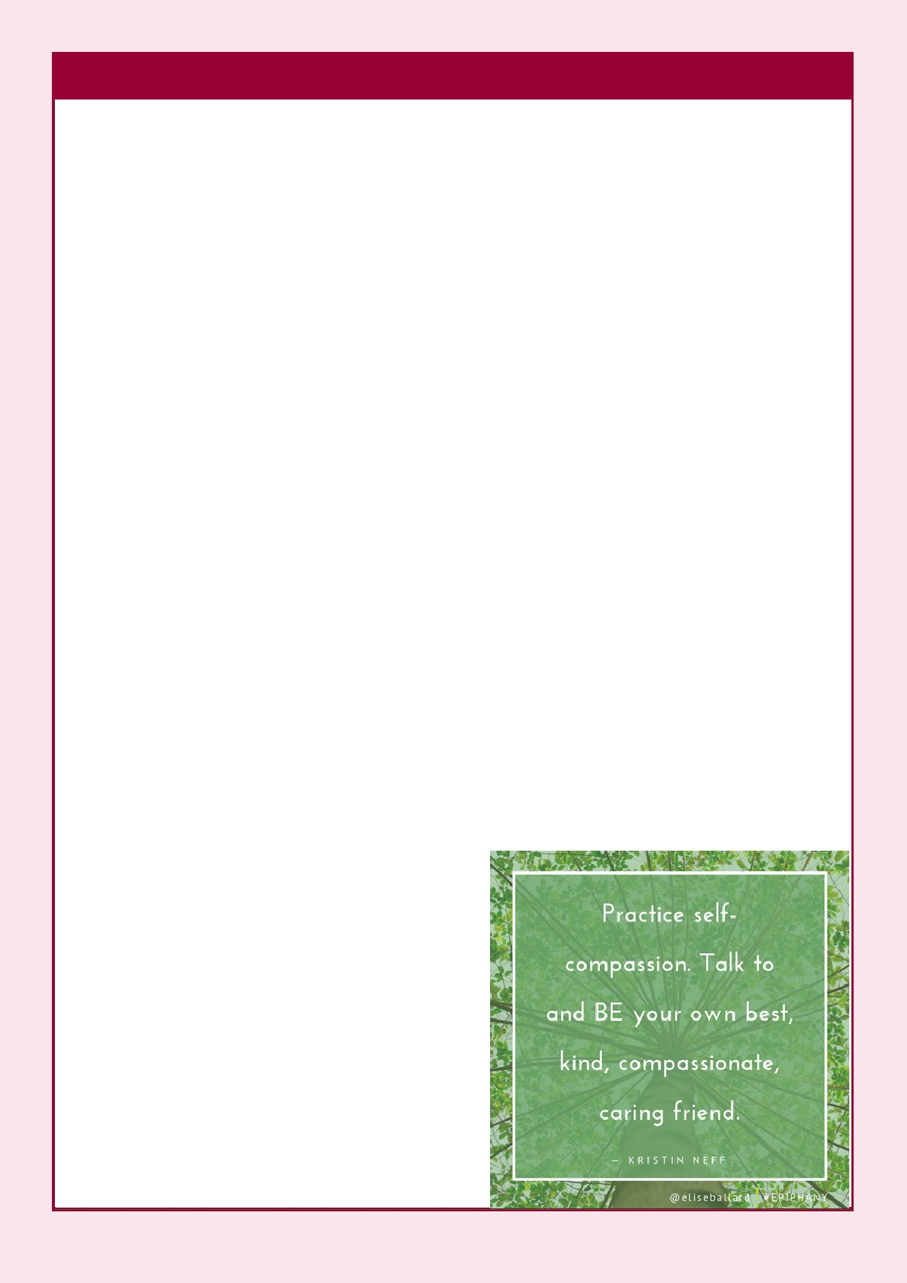ISSUE 2 Page 5
Dr Kristin Neff is one of the leading pioneers in researching the benefits of
self-compassion on our mental health. Her research has found that it can have a positive effect on anxiety and depression, reduce levels of stress and improve
our relationships with others. She has developed numerous exercises and meditations to help cultivate self-compassion, one of which is a 5-minute
self-compassion break, which we can use anytime we need a 'comfort' break
from our stresses. Here's a little taster:
1) Take some deep breaths and observe how you are feeling,
for example notice if you are feeling stressed.
2) Acknowledge that its ok to feel stressed, it's a part of be-
ing human.
3) You may wish to place your hand on the part of your body
where you are feeling the stress the most.
4) Offer yourself a self-compassion phrase such as "May I be
kind to myself in this moment".
5) Repeat the phrase and allow a feeling of compassion to
generate.
6) Offer feelings of care and kindness to yourself and imagine
it flowing out through your hand and into your body.
7) Offer any other kind words to yourself that you need to
hear.
8) Notice how your body feels now, just as you are, in this
moment.
9) Take a couple of deep breaths and carry on with your day.

For more of Kristin Neff's research and
exercises visit www.self-compassion.org. If
you enjoyed this taster and would like to
learn more about self-compassion, we
offer a range of courses that explore this
topic; Compassion in a Nutshell, How
Compassion can Change your Brain, and Practical Mindfulness. We also touch on
this topic in our Anxiety Management and
Building your Self-Esteem and Assertive-
ness courses. If you are interested in
attending any of our courses, please use
the contact details on the back page to get in touch and book your place.

Page 6 INSPIRE
Tips for Staying Well in Winter
Winter can be a difficult time of year and so we've gathered some quick tips on
how best to look after your mental and physical wellbeing during this season:
• Get outside during daylight hours. Fresh air is good for the body and mind.
Being exposed to sunlight can improve our mood as it increases our Vitamin-
D levels, and being amongst nature can help us to focus on the present
moment. Try to go outside as often as you can, even just for a short time.
• Move your body in a way that's right for you. Finding the motivation to
exercise in Winter can be difficult, but even a small amount of movement
can help our bodies to produce endorphins which can have a positive impact
on our overall mood. Moving your body doesn't always have to be about
intense exercise like running, cycling or going to the gym. Simply stretching
your muscles can have a positive impact, and remember that doing activities such as gardening or housework can also be good ways to get moving.
• Connect with other people. In light of the pandemic, this one may be
particularly challenging. Staying in touch with other people, even if it needs
to happen virtually rather than face-to-face, can help lift our mood and
ensure that we feel supported. If you are on social media, we have a Facebook group in which our students can connect and chat with one
another. If you'd like more details about this, please do get in touch with us.
• Eat a balanced diet. In winter we tend to reach for comfort foods. That's OK,
but it's also important to eat nutritious foods to give our body the
energy it needs. Make the most out of seasonal fruits and vegetables that taste better in the winter, for example citrus fruits.

Image by Alain Audet from Pixabay

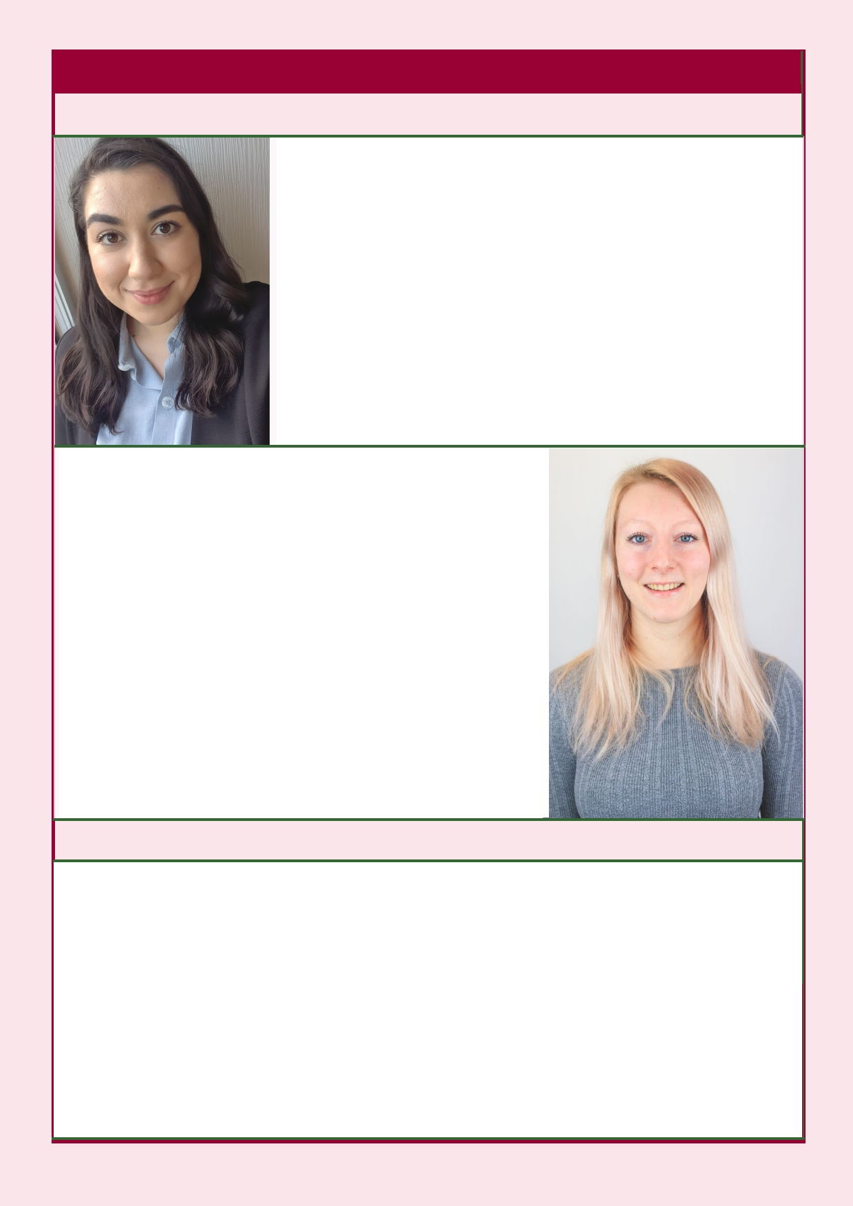Page 7 INSPIRE
Welcoming Naima and Beth to the Team
Hi, I'm Naima and I'm a BSc Psychology student at the
University of Sussex currently on placement at the
college as a Trainee Admission Tutor and Trainer. My interest in psychology started early in life when I was dealing with my own personal struggles with mental
health. I find that recovery education can be extremely powerful and I'm very proud to be supporting others in
their own recovery journey during my time at the
Wellbeing and Recovery College. I practice yoga everyday as I find it very beneficial to my overall
wellbeing and in my spare time I also enjoy reading, playing tennis and going to live events.

My name is Beth and I am studying Neuroscience
at Aston University and am currently in my 3rd year
(my placement year). I am completing my place- ment year at the Wellbeing and Recovery College
as a trainee trainer and admissions tutor. I am
proud to be part of the Wellbeing and Recovery
College, it has been a really rewarding experience
so far. Through my various roles within the college I
help to support people in understanding and
coping with their mental health struggles in daily life. I have several hobbies including photography, pole fitness, climbing and throwing the javelin, the
latter of which I have competed for the Senior
Welsh team and GB U23 team at competitions in the UK and abroad.
Anne Marie's Story
I'm Anne Marie and work within Midlands Partnership NHS Foundation Trust as
an Occupational Therapist within the Chronic Fatigue Syndrome Service at
Cannock Chase hospital. I have been involved with the Recovery and Wellbeing
college for a number of years now and love the ethos and informal, relaxed
atmosphere of the college. Working jointly with lived experience trainers I am
involved in the Understanding Chronic Fatigue Syndrome and Understand- ing Fibromyalgia workshops. I really enjoy these sessions, working alongside trainers and meeting service users, their friends or family members and pro-
fessionals all of whom want to increase their knowledge and understanding of
these conditions. We want people to feel empowered by the sessions and I have found each workshop undertaken a thoroughly rewarding experience.

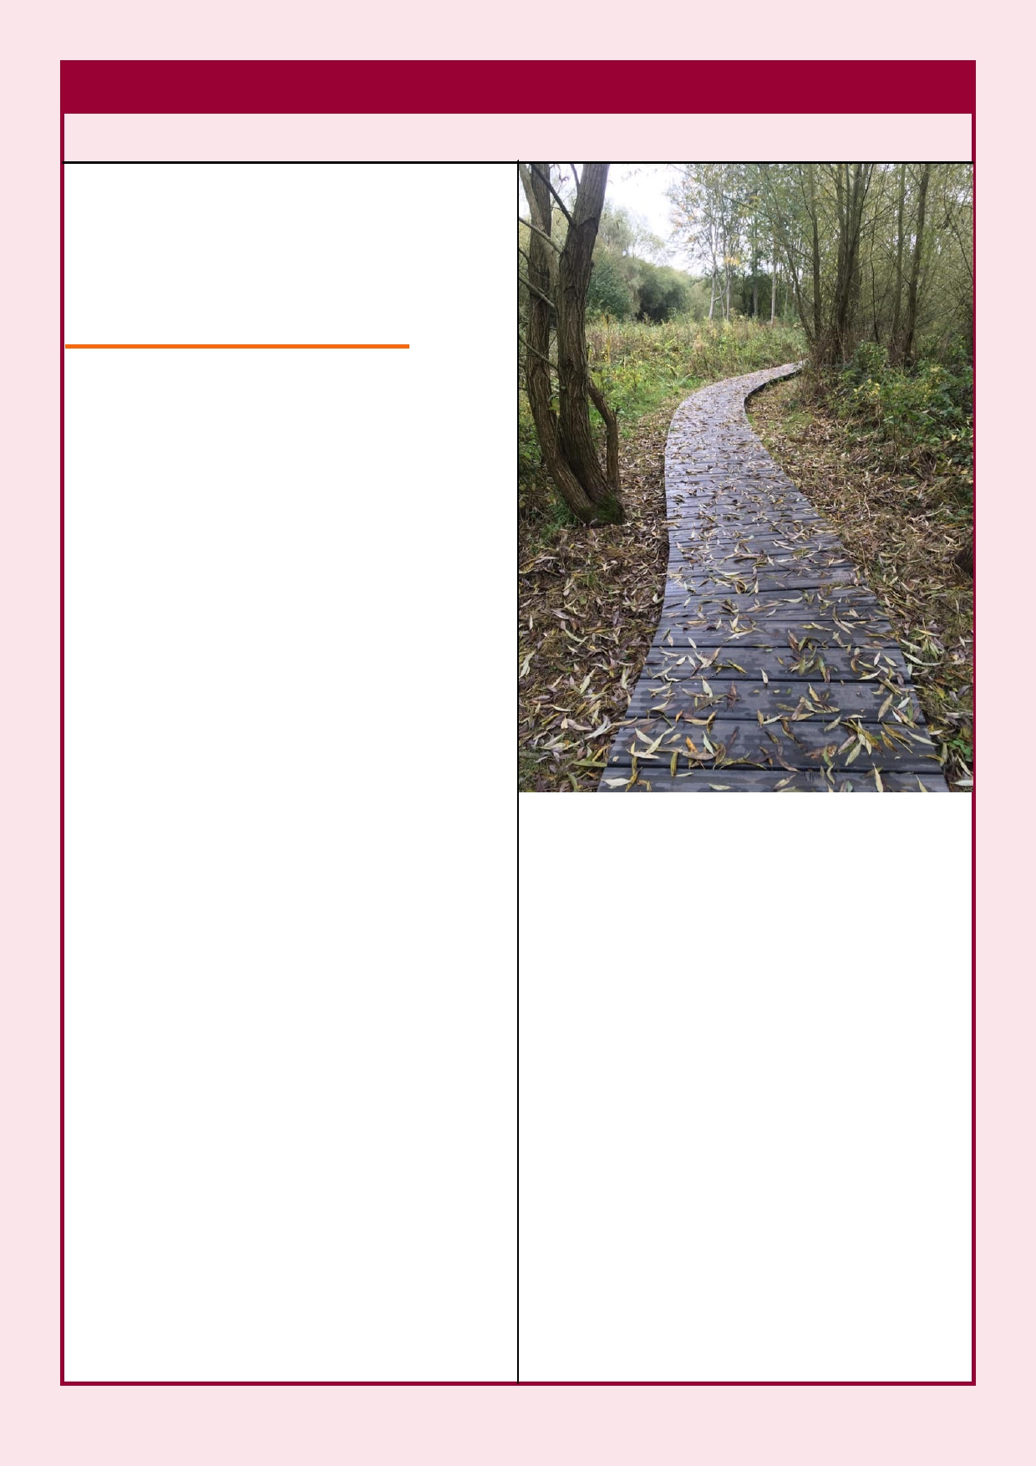Page 8
What Have Our Students Been Up To?
Juliet enjoys writing poetry and
wrote this beautiful piece about
Autumn:
The Scent of Autumn
Seeing the Autumn colour glow,
Hearing the crispy leaves, As you walk on your way
See them flutter down

They flutter down so gracefully,
Swaying and switling,
'til they hit the ground.
But this does not mean the end.

This just means they need a rest, From all the support they gave us.
They give to us through the months,
The happiness of seeing them dancing.
INSPIRE

Dancing in the warm breeze,
Just drifting by to say hello,
Giving us the breeze
"A Path Through Autumn"
by Karl

That we needed on the hot summer days. Karl enjoys photography and has

So now has come their time to rest,
Rest their bodies,
Rest their branches,
'til the Spring when they will peak again.

So for now just enjoy the moment,
Enjoy the beatufiul scents of Autumn,
Enjoy the vibrant colours,
Please remember it's not the end, it's just a rest.
by Juliet
shared this photo with us. He said "This is one of my Autumn favour-
ites, I think it's the way you are drawn into following the path. I started taking photos for fun, as
a hobby, and to improve my well- being. I find it a way of expressing myself without being seen. To me, they are my Mindful Reflections."

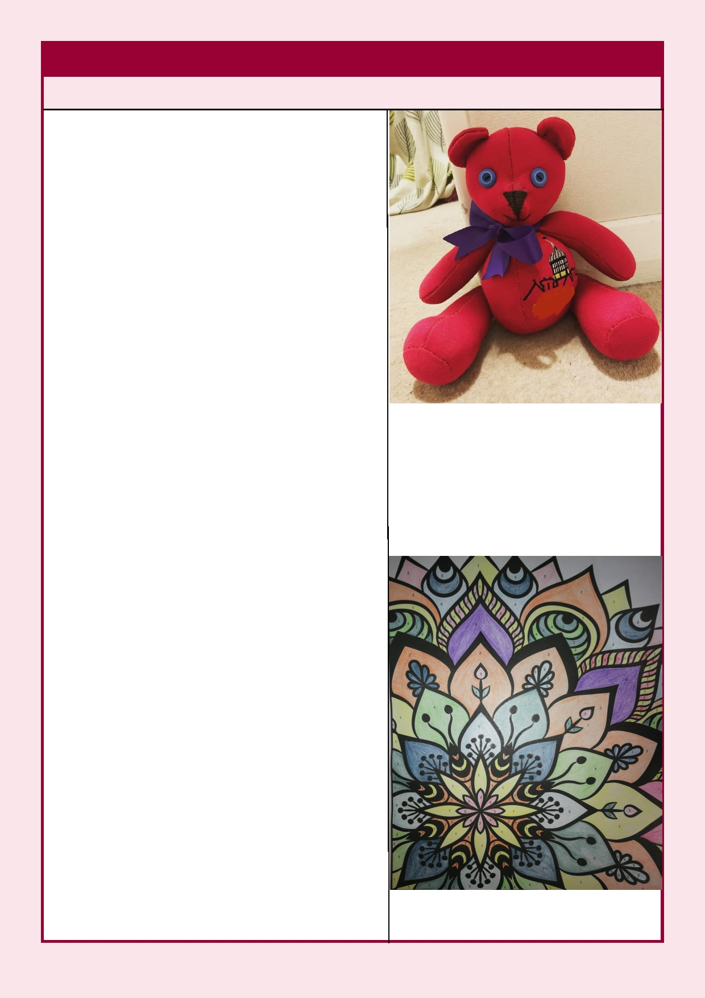Page 9
What Have Our Students Been Up To?
Marilyn wrote this lovely acrostic poem
about the Wellbeing and Recovery
College:
Wellbeing and Recovery College welcoming
Everyone to
Live and
Learn
By
Enjoying and engaging
Informally in sessions,
Normally in
Groups around the county, so they're
INSPIRE

Accessible to everyone. A
Numerous choice of
Diverse topics of

Recovery focused
Education. Try
Craft Your Way To Mindfulness
Or, Understanding Depression. They're currently
Via Zoom
Ensuring they
Reach
You during

Coronavirus
Online sessions like the Wellbeing Toolkit,
Learn about PTSD or Understanding Anxiety. Listen to professionals and people with lived
Experience, so Go ahead and
Enrol today.

by Marilyn

Kate has been making 'Memory Bears' by sewing clothing items together.
Kate said "It's a keepsake bear made
from keepsake clothing items. I've
made them from babies' first outfits and other special items of clothing."
We think they're a lovely keepsake!

This beautiful Mandala colouring was done by Laura.

Page 10 INSPIRE
A Big Thank You
We would like to say thank you to all of our students for your continued
support throughout this year. We hope that you have all enjoyed learning in a
new way this term and that you are looking forward to joining us again in 2021.
We also thank our trainers. Without you, we would not have been able to
deliver the wide range of courses that we have had on offer. We are incredibly
grateful for your dedication and support, and we are looking forward to working with you all again in the Spring.
What are your thoughts?
In everything we do at the college, we really value your feedback and ideas. INSPIRE is a newsletter that we create each term for you: our students and
trainers. We would really like to hear from you regarding the type of content
you would like to see in our newsletter, including any topics you'd like us to
write about and any information that would be helpful. We are looking to
expand our 'What have our students been up to?' section, so we welcome your
poems, photographs and stories. To submit something to our newsletter, or if
you have any thoughts you'd like to share with us regarding the type of content you'd like to see, please get in touch using the contact details shown below.

About Us
We are the Midlands Partnership NHS
Foundation Trust Wellbeing and Recovery
College. Here at the college, we aim to provide
wellbeing and recovery focused educational
courses that are accessible to everyone within our local communities across Staffordshire and Shropshire. We work together with our growing community of students to create a safe learning
environment to promote hope, control and
opportunity for all. Our courses bring together an equal blend of professional, carer and lived
experience trainers who encourage shared learning, where we can all learn from one
another through the sharing of each individual
journey towards wellbeing and recovery.
If you are interested in one of our courses but
haven't yet enrolled with the college, please get
in touch with us via your preferred method to arrange an enrolment appointment. There you
will be invited to complete an individual learning
Contact Us
Direct Line:
01785 221257
Switchboard:
0300 790 7000
ext: 7128607
Mobile:
07891 099460
Email:
wellbeingREC@mpft.nhs.uk
Facebook:
Wellbeing and Recovery
College MPFT
Twitter:
@reccollegempft
Instagram:

plan with a member of our team. Please also get @wellbeingrecoverycollegempft
in touch if you are interested in being involved

with the Wellbeing and Recovery college team;
we'd love to hear from you!
Website:
https://recovery.mpft.nhs.uk/

