**Sleeping Well – Sleep Cycle**

[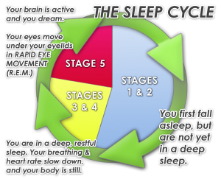](http://www.google.co.uk/url?sa=i&rct=j&q=&esrc=s&source=images&cd=&cad=rja&uact=8&ved=0ahUKEwibsPe0sf7UAhUTOsAKHX8DAfkQjRwIBw&url=http://www.kea0.com/sleeping-cycle/&psig=AFQjCNHBHUtqfUwdELVZkDwNXhN4zzdEpw&ust=1499764488603288)

[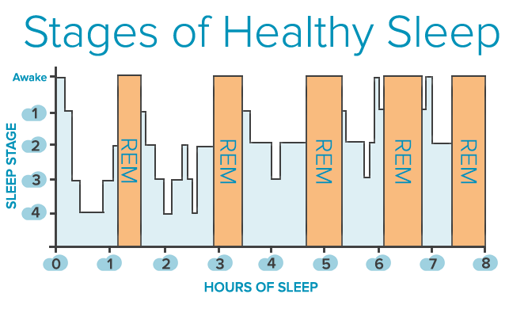](http://www.google.co.uk/url?sa=i&rct=j&q=&esrc=s&source=imgres&cd=&cad=rja&uact=8&ved=0ahUKEwjcqo7bsv7UAhWsCcAKHZ8PAOcQjRwIBw&url=http://www.centerforsoundsleep.com/sleep-disorders/stages-of-sleep/&psig=AFQjCNE_EZuSfH3vZUEvh2Bk1ar9OVIxEA&ust=1499765152975274)

(5th stage)

(5th stage)

(5th stage)

(5th stage)

(5th stage)