9 best foods to eat before bed to enhance your sleep quality
1. Almonds
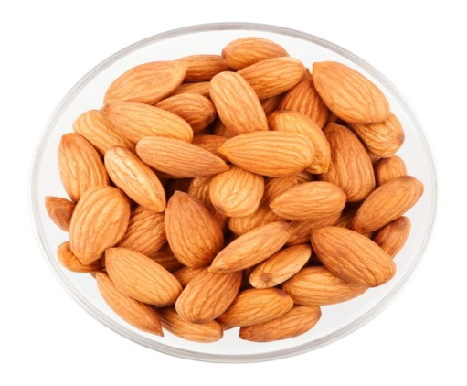
Almonds are a source of melatonin and the sleep promoting mineral magnesium, two properties that make them a great food to eat before bed.
2. Turkey
Turkey may be a great food to eat before bed due to its high content of protein and tryptophan, both of which may induce tiredness.
3. Chamomile Tea
Chamomile tea contains antioxidants that may promote sleepiness and drinking it has been shown to improve overall sleep.
4. Kiwi
Kiwis are rich in serotonin and antioxidants, both of which may improve sleep quality when eaten before bed.
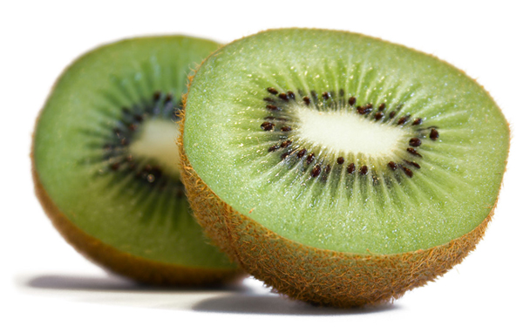
5. Tart Cherry Juice
Tart cherry juice may help induce a good night’s sleep because of its content of the sleep-promoting hormone melatonin.
6. Fatty fish eg salmon, tuna, trout or mackerel
Fatty fish are a great source of vitamin D and omega-3 fatty acids, both of which have properties that may improve the quality of your sleep.
7. Walnuts
Walnuts have a few properties that may promote better sleep, including their content of melatonin and healthy fats.

8. Passionflower Tea
This may influence sleep due to its content of the antioxidant apigenin as well as its ability to increase GABA production (ie a brain chemical that works to inhibit other brain chemicals that induce stress.
9. White rice
White rice maybe beneficial to eat before bed due to its high glycemic index which may promote better sleep.
Other foods that may promote sleep
- Milk; Another known source of tryptophan, milk has shown to improve sleep in the elderly especially when taken along with melatonin and exercise
- Bananas; contain tryptophan and a good source of magnesium, both which might help you get a good night’s sleep.
- Oatmeal; high in carbs and has been reported to induce drowsiness when consumed before bed. Also they are a known source of melatonin.
- Cottage cheese; contains a significant amount of casein which is a milk protein that is well known to sustain overnight muscle repair and growth when consumed before bed.

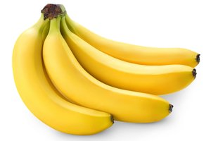
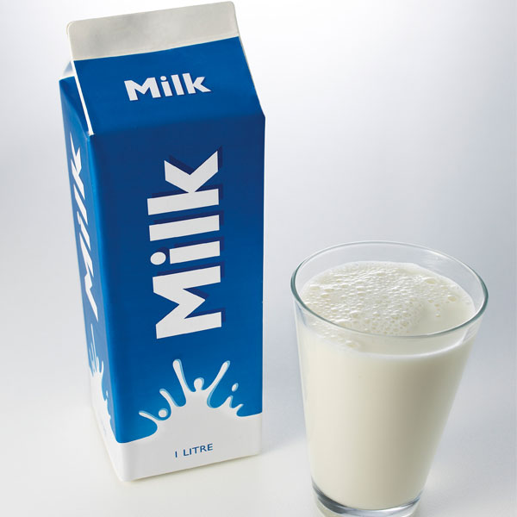

Some foods that may have a negative impact on sleep:
Alcohol: Despite what some people say, alcohol has a negative impact on sleep and a “night cap” is not as effective as some people believe. Alcohol can inhibit our ability to enter the “deep sleep” phase of the sleep cycle and so we wake up not feeling as refreshed as we should.
Coffee: Due to the caffeine content and also because coffee is a bladder irritant and may cause us to need to go to the toilet.
Chocolate: Due to the caffeine content – Dark chocolate in particular contains a lot of caffeine and can therefore stop us from falling asleep
Watermelon/Food with high water content: This is because it may disturb our night of sleep due to needing a bathroom trip
