Anxiety Management and Relaxation Techniques

Adapted by Laura Fox | Peer Support Worker | Cannock Chase CMHT

Why is relaxation important?
Anxiety makes the body tense and when this becomes a habit it alerts the nervous system. This makes us think we are in danger which releases stress hormones, such as adrenaline. By making sure the relaxation is part of your daily routine it can help prove to your body that there is no danger as it helps you get used to being relaxed. Relaxation can also help regulate your breathing and think more rationally.
Adapted from http://www.nopanic.org.uk/relaxation-technique/

Why is breathing important in relaxation?
Hyperventilation accompanies most panic attacks. The body thinks it doesn’t have enough oxygen when in reality hyperventilating means that the body is taking in TOO MUCH oxygen. This is why many people with anxiety feel light headed, dizzy, have chest pains, sweat more, feel tired and short of breath. By making sure you are breathing correctly it restores balance to your oxygen and carbon dioxide levels.
Adapted from: http://www.nopanic.org.uk/important-breathe-properly-help-anxiety/

Simple Relaxation Technique
This breathing technique will work best if you make it part of your daily routine. You can complete this exercise sitting, standing or lying down as long as you make sure you are comfortable.
Before you start:
If you are lying down: make sure your arms are a short distance from your sides and that your palms are facing upwards. It works best if your legs are straight or if they are bent make sure your feet are flat on the floor.
If you're sitting down: make sure your arms are resting on the arms of the chair and that the seat is supporting your back.
If you are standing: your feet need to be flat and hip-width apart
~ Now you are in a comfortable position ~
•Breathe as deep as you are comfortable with. They key is to be comfortable so do not force yourself to breathe deeply. Breathe regularly and gently. Close your eyes if this helps to make you feel relaxed.
•Breathe in through your nose and out through your mouth.
•When you breathe in count steadily from one to five. Do the same for when you breathe out.
•In between breaths do not pause or hold it in. Make sure your breathings flows.
•Keep doing this for three to five minutes.
Adapted from: http://www.nhs.uk/Conditions/stress-anxiety-depression/Pages/ways-relieve-stress.aspx

Square Breathing Technique
This is a breathing technique that can be used for relaxation or to help regulate your breathing when you are having a panic attack. It takes practice to develop this skill and you may find that when you first try it during a panic attack that it takes a while to regulate your breathing. As with any relaxation technique, making it a part of your daily routine will help you feel more of a benefit.

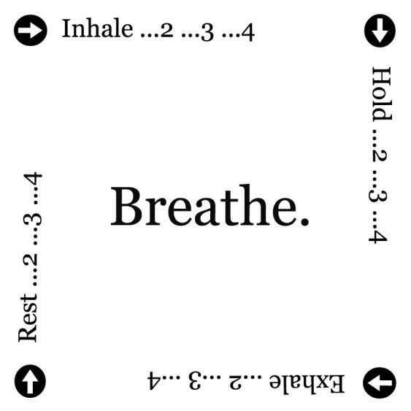

Instructional video available at: https://www.youtube.com/watch?v=mgzhKW08bMQ
Before you start: Make sure you are sitting in a comfortable position – back straight, hands relaxed, feet flat on the floor. Close your eyes if this helps. You can also do this when you are standing e.g. relaxing your arms and hands whilst you are in a queue for the bus or a checkout and you are feeling anxious.
- Breathe in and in your head say “In 2, 3, 4”
- Hold and say in your head “hold 2, 3, 4”
- Breath out and say in your head “out 2, 3, 4”
- Hold and say in your head “hold 2, 3, 4”
- Repeat this process as needed. Count in your head in a way you feel comfortable. Don’t force breaths and make sure you are as comfortable as possible. You can do this without other people noticing you are doing square breathing so the breaths don’t have to be really deep e.g. if you are doing it to calm your nerves when you are in public.
- Try to visualise the square in the image above and focus on counting and your breathing. This will be helpful to you if you are feeling very anxious and out of control.

Diaphragmatic Breathing
This exercise is useful for regaining control of your breathing.
- Place a hand on your stomach and another on your chest
- Close your eyes and make sure your posture is relaxed.
- Take 2-3 slow, deep breaths at a time. Try to push out your lower hand with your abdominal muscles. You will find that your lower hand will move more than the hand on your chest the deeper you breathe.

Relaxation for Walking
Useful for social anxiety
- Breathe in for three steps
- Breath out for three steps
- Relax for three steps
- Repeat above steps as needed.

Safe Space Technique
- Find a quiet place where you feel comfortable and won’t be distracted. It is best to sit in a chair or lie down.
- Make sure your posture is relaxed. Take a few moments to get comfortable so your body feels loose and heavy. It can help to focus on how your body meets the chair or bed and to let it completely support your weight.
- Close your eyes and breathe normally. Don’t force your breathing. This step is for you to just concentrate on your breathing for a moment.
- Think of a word you associate with being comfortable, relaxed and safe. Say this word in your mind each time you breathe out. You can also imagine a place where you feel safe. Do this this imagine sensations of that plae. What can you see, smell, hear etc?
- Allow yourself to do this for 5 – 15 minutes
- When you have finished slowly become aware of your surroundings.

Grounding
This technique is helpful for when you are feeling very overwhelmed by anxiety or having a panic attack. We can feel out of control of our body and surroundings in those situations, almost like we are not really in reality. Grounding can help you “ground yourself back into reality.”

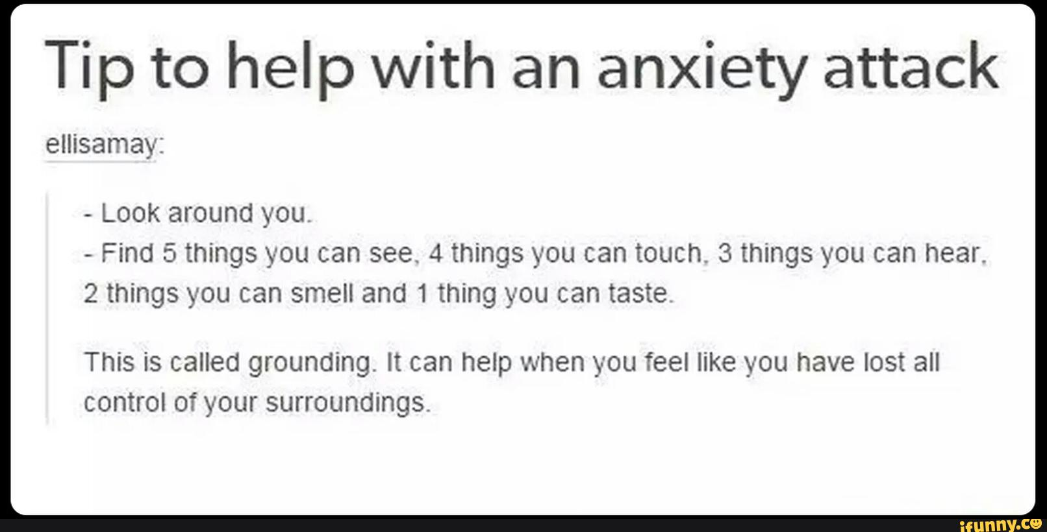

Image available from: https://ifunny.co/fun/00XJwbC63/comments?gallery=tag&query=grounding
Grounding can also be used to help you if you have flashbacks or nightmares. It is all about engaging with the environment, using your five senses and regaining control. It takes some time to practice but if you persevere you will feel the benefit.

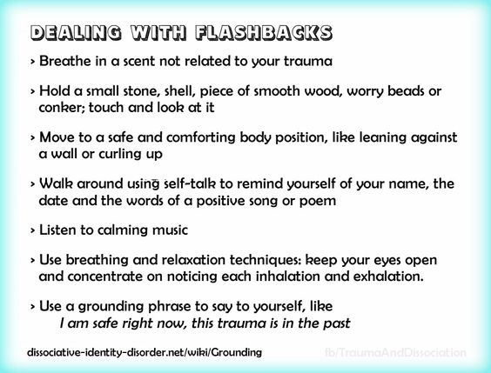

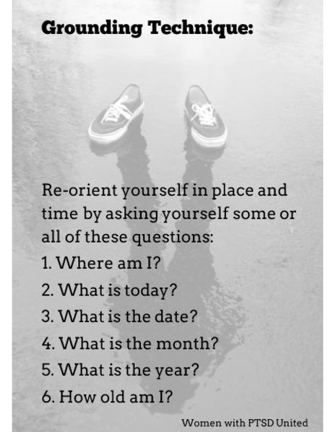

Image available at: http://www.womenwithptsdunited.org/grounding-techniques---relaxation.html
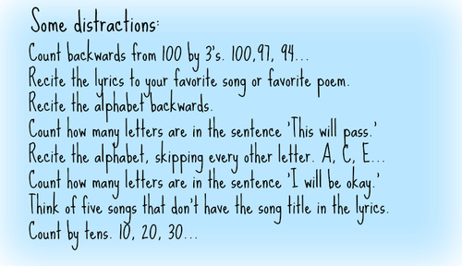

Image available at: https://31.media.tumblr.com/7ed10d62877d771ea27ed6f839852ed8/tumblr_inline_nkpemqcRlQ1tnwk9b.jpg
Getting the body used to the difference between tension and relaxation
When you have been struggling with anxiety it can be hard to remember a time when you felt relaxed. This deep muscle relaxation exercise can help your body recognise the difference between feeling relaxed and tense.
The following is from: http://www.nopanic.org.uk/relaxation-technique/
With each body part:
• Start now and count steadily to ten, notice the tension.
• Relax the body part you are focusing on.
• Notice the difference between tension and relaxation in this body part • Keep focusing on the word relax.
Body parts to do this exercise with:
- Begin with The muscles in your hands and forearms: You tense these muscles by clenching your fists as tightly as you can.
- The muscles in your upper arms: You tense these muscles by bending your arms at the elbows and trying to touch your wrists to your shoulders.
- The muscles in the back of your arms: You tense these muscles by straightening your arms as hard as you can.
- The muscles in your shoulders: You tense these muscles by shrugging your shoulders tightly into your neck.
- The muscles in your neck: You tense these muscles by pressing your head back as far as you can.
- The muscles in your forehead: You tense these muscles by raising your eyebrows as though enquiring.
- The muscles in your brows and eyelids: You tense these muscles by frowning and squeezing your eyes tightly shut.
- The muscles in your jaw: You tense these muscles by clenching your teeth as hard as you can.
- The muscles in your tongue and throat:You tense these muscles by pushing your tongue against the roof of your mouth.

10. The muscles in your lips and face: You tense these muscles by pressing your lips together tightly.
11. The muscles in your chest: You tense these muscles by taking a deep breath and holding it.
12. The muscles in your stomach. You tense these muscles by making your stomach muscles hard as though expecting a punch.
13. The muscles in your hips and lower back: You tense these muscles by arching your back and clenching your buttocks.
14. The muscles in your legs and feet: You tense these muscles by straightening your legs and pointing your toes down.
Now completely relax for 10-15 minutes and let the feeling of relaxation spread throughout the whole of your body. Keep focusing on the word relax and enjoy that feeling of deep relaxation. Try and return to your daily activities keeping the body as relaxed as you can

Useful apps and websites
Apps:
- Headspace
- Calm
- Dare – Break Free From Anxiety
- Pacifica
- Self-Help Anxiety Management
- InnerHour
- 7 Cups – Anxiety and Stress Chat
- Meditation and Relaxation: Guided Meditation
- Worry Tree
- PanicShield – Panic Attack Aid
- Stop, Breathe & Think
Websites:
- Mind.org.uk
- Sane.org.uk
- Mentalhealth.org.uk
- Rethink.org.
- Together-uk.org
- Anxietyuk.org.uk
- Nopanic.org.uk
- turn2me.org/Free-Anxiety-Help
- moodjuice.scot.nhs.uk/anxiety.asp
- social-anxiety.org.uk
- NHS Choices
- time-to-change.org.uk
- bemindful.co.uk
- youtube – type in meditation, mindfulness, relaxation

