[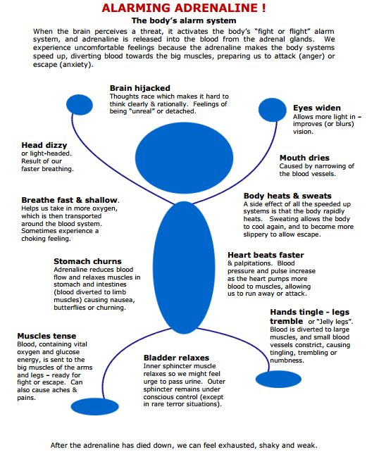](https://www.getselfhelp.co.uk/adrenaline.htm)