[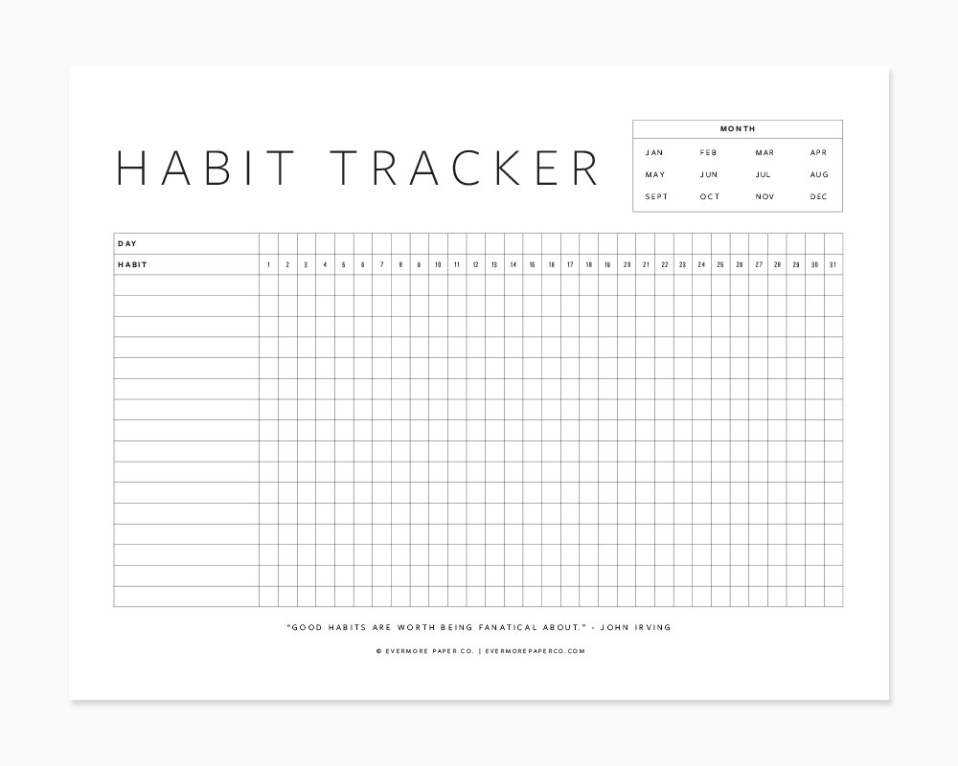](https://www.google.com/url?sa=i&rct=j&q=&esrc=s&source=images&cd=&ved=2ahUKEwiJ4d24wP7fAhWNMBQKHRf5BusQjRx6BAgBEAU&url=https://evermorepaperco.com/blog/2017/free-printable-habit-tracker&psig=AOvVaw2pkl0OQnvZmYyuoylAJaM0&ust=1548147320433926)