Joining a Zoom meeting from an iphone

Go to <https://zoom.us> or download the app on your phone which looks like this.

Once you have the loading page open, you will see this screen. If this is the first time using Zoom, press ‘join’.

The next step is to join the meeting

Enter the Meeting ID provided to you by the college

Next, you will be sent an email asking you to verify your account. If you don’t receive an email, check the address is correct and press resend.

The next step is to enter the password provided by the college

This is what you will see if we haven’t started the meeting yet

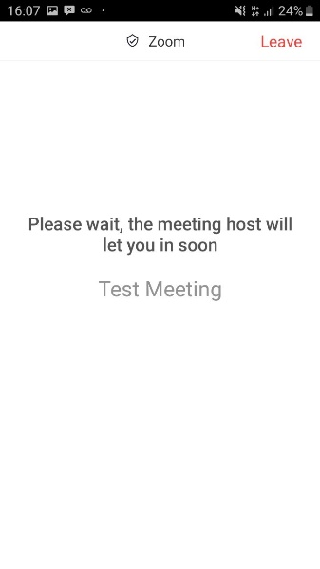

This is what you will see if you are in the waiting room



This is what you will see if we haven’t started the meeting yet

Basic Zoom functions from an iphone

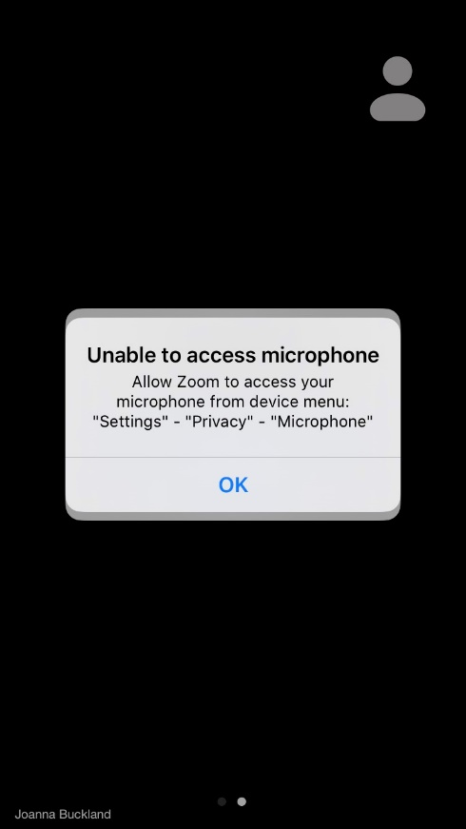

If your permission settings are set to always ask permission from apps to use features such as your microphone and camera, you will see a message like this. By clicking ‘OK’ to microphone and camera, you will be able to hear and see others and have the option to turn your camera on or have your sound muted

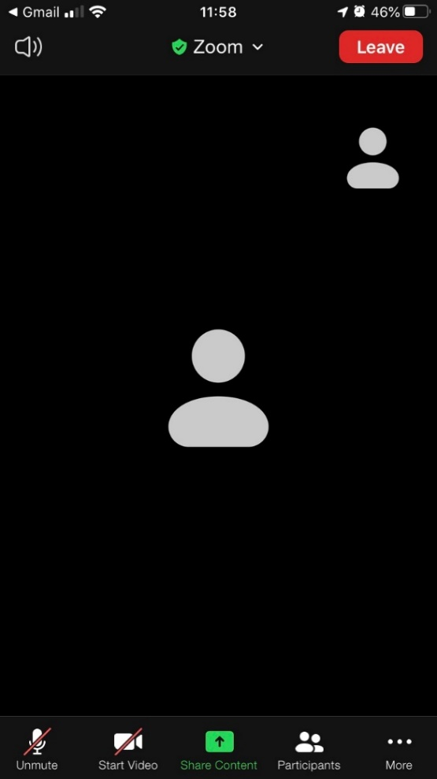

When you start, your video will automatically be off and you can choose to start or stop your video using this function

You can mute or unmute using this function

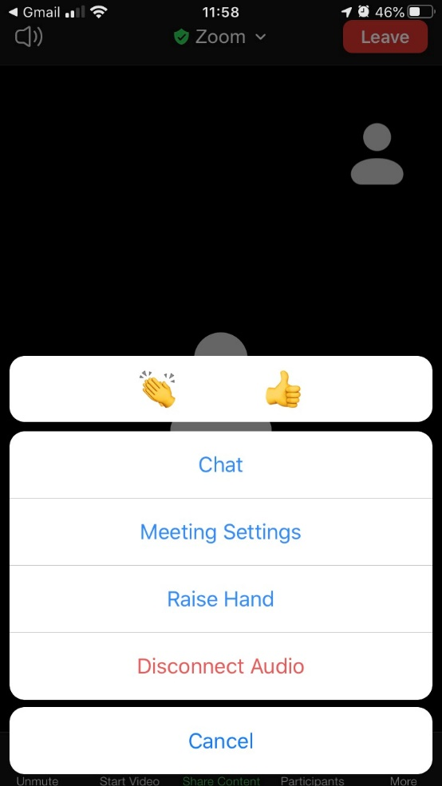

At the bottom of your screen, you can see three dots ‘more’. When you click that you

* can raise your hand to get trainers attention
* chat (there is a separate chat function which trainers will show you when the course starts)
* Hide non-video participants
* Show your name (you should be able to amend your name here too) This will also be shown with trainers when course starts