Guidance Notes for accessing and using Zoom via laptop

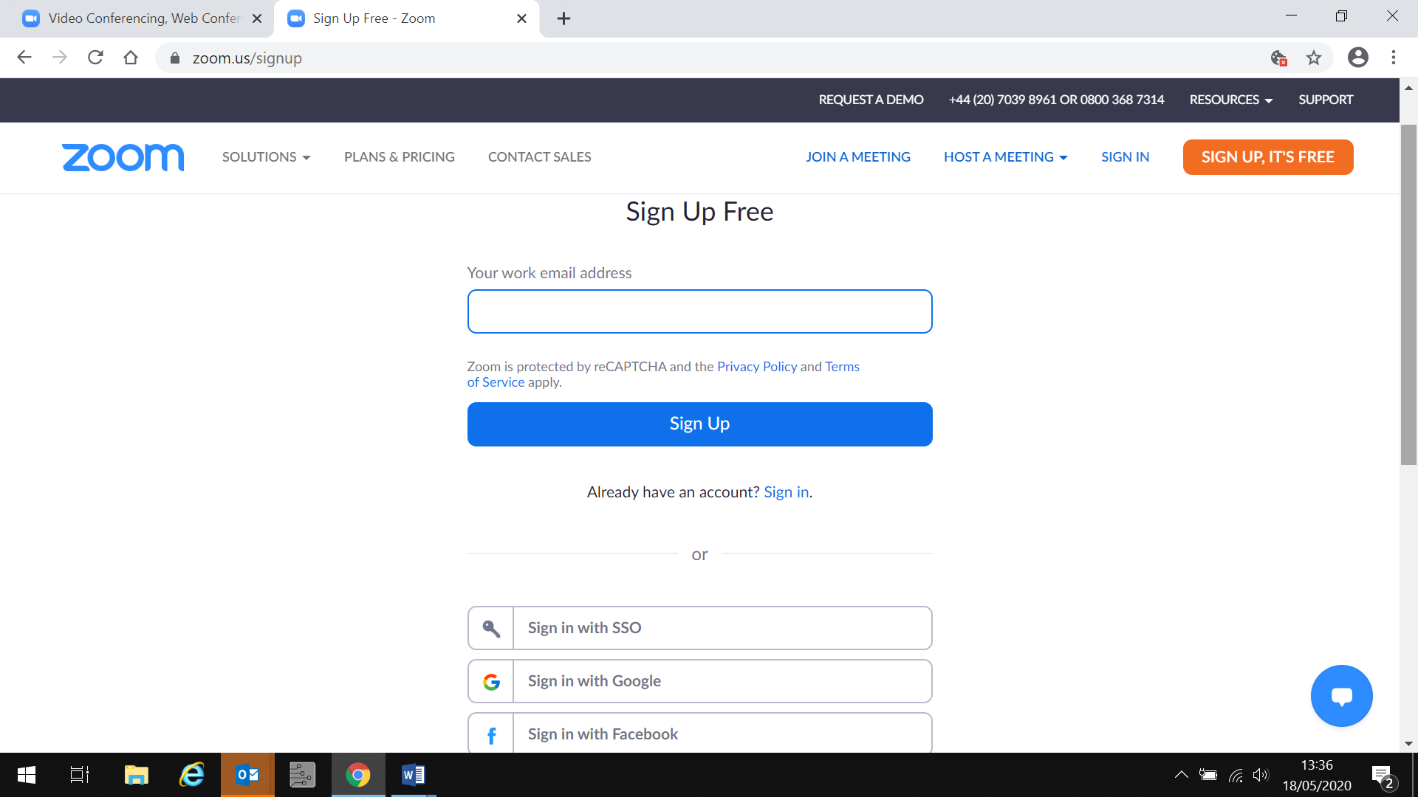

You can create your own Zoom account via the website <https://zoom.us/>

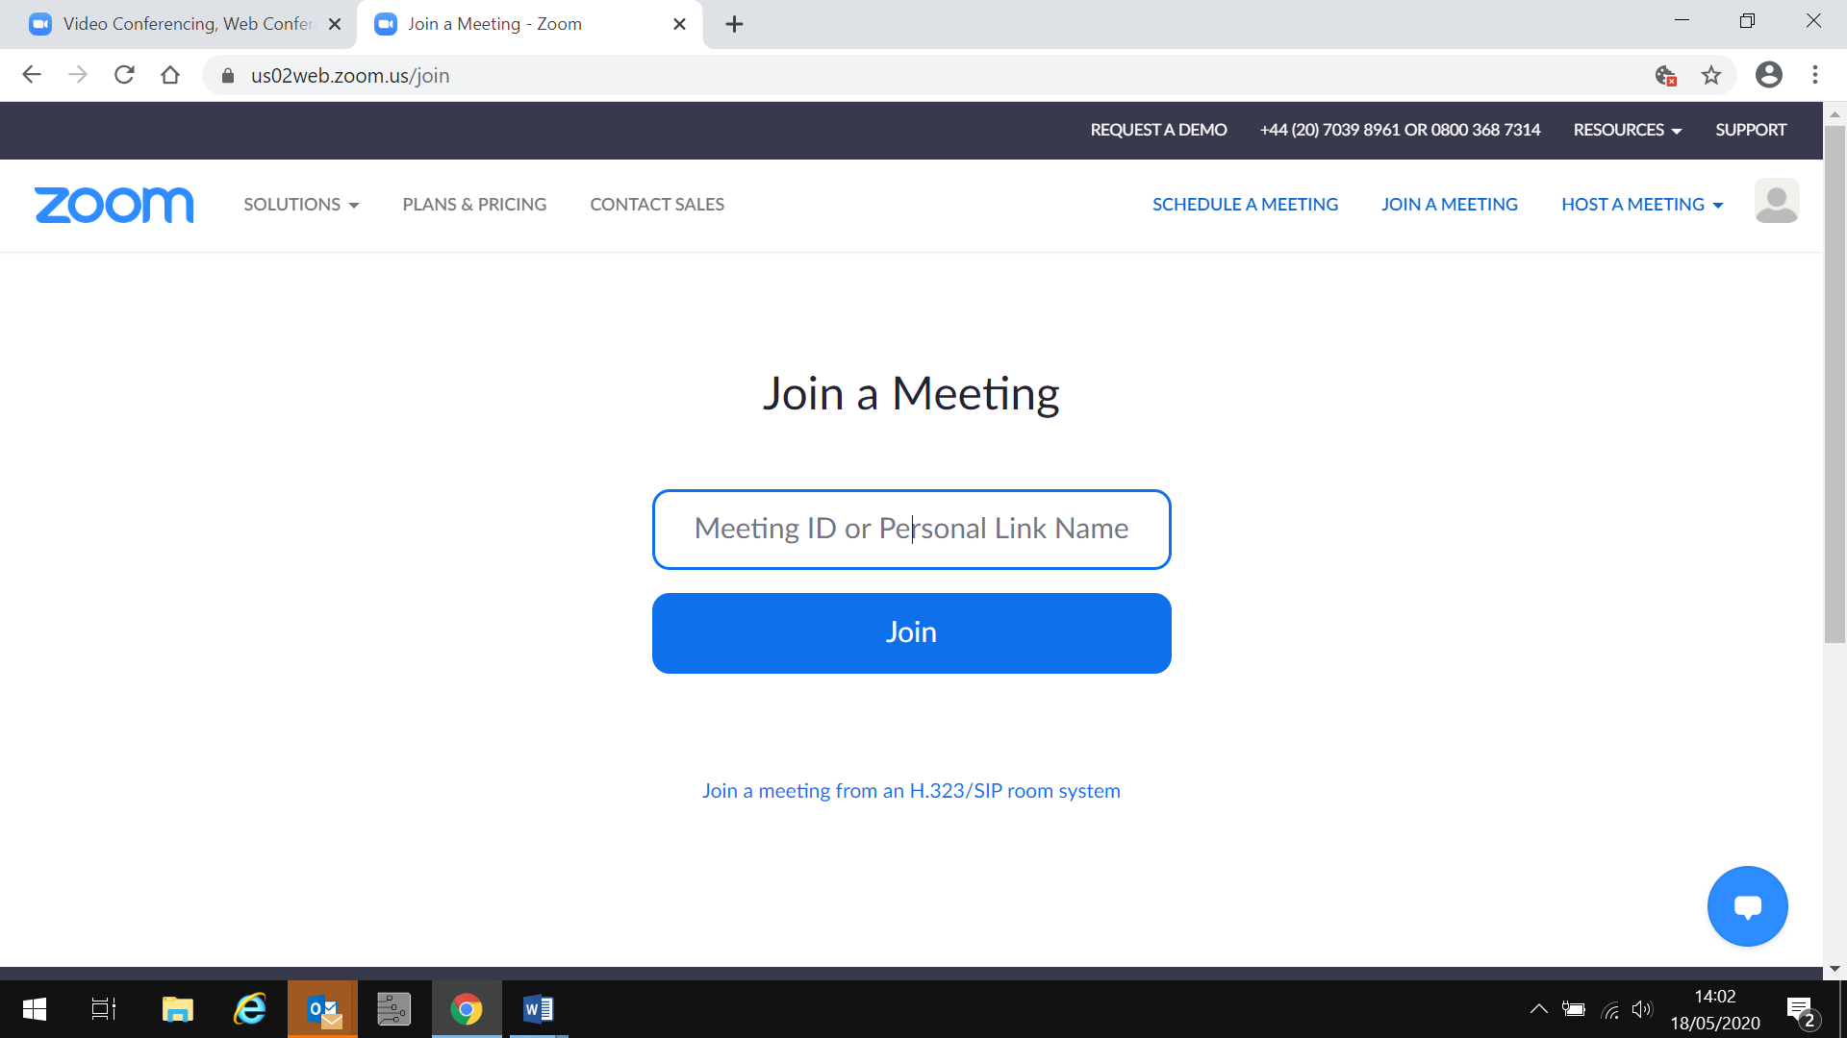

It is not essential to have an account to join a session, you can simply click onto the join a meeting tab.

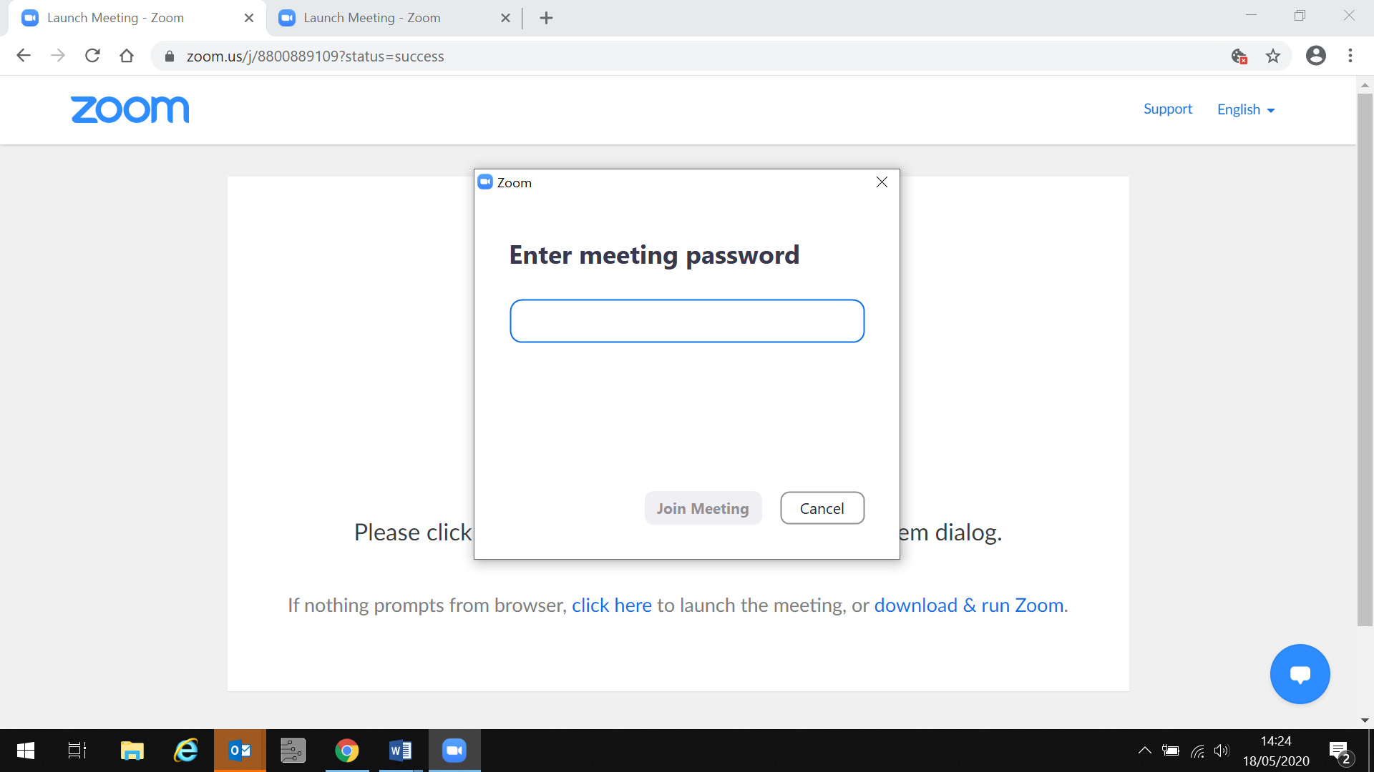

You can then join a session by inputting themeeting ID (which will be sent to you 48 hours prior to the course session starting. Then click join, you will be asked for a password which we will also send to you 48hrs prior.

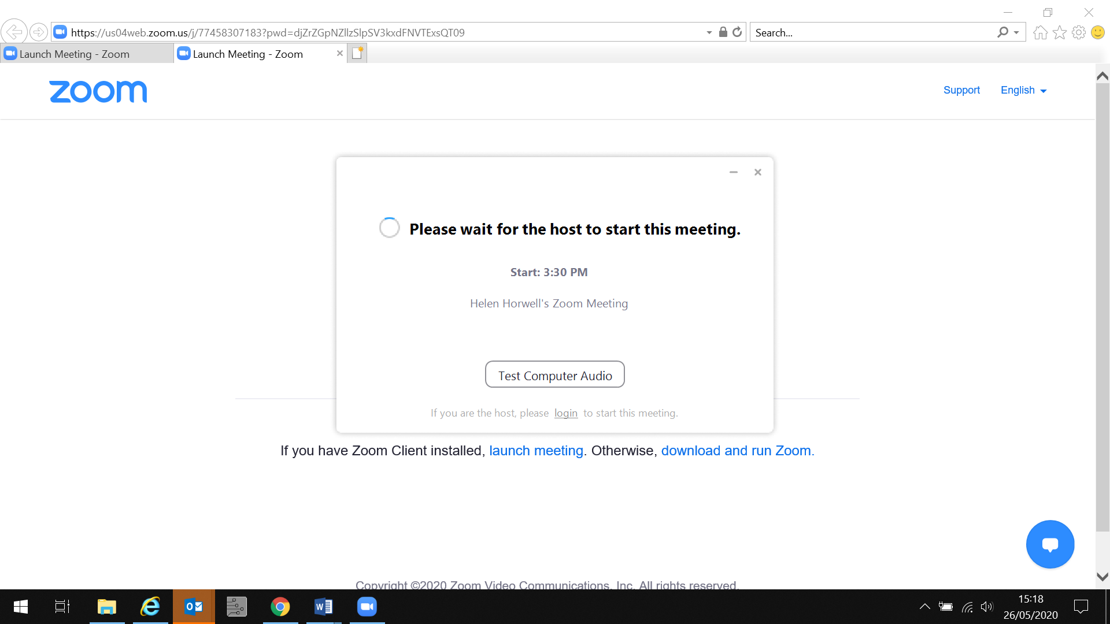

You will see a message to indicate that the host has not yet started the session.

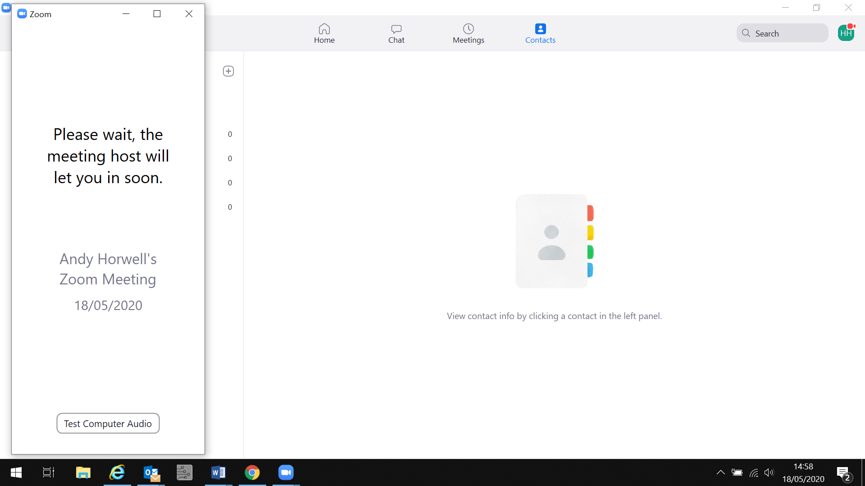

You will see a message to indicate that you are in a waiting room and your host will start the session and let you join.

When you are admitted to the course session, your video will not be shown and your microphone will be muted. You will still be able to continue with the session even if you wish to keep your video off.

Your microphone will stay muted throughout the course to deter background noise, unless you are in a break out room undertaking discussions with other students.

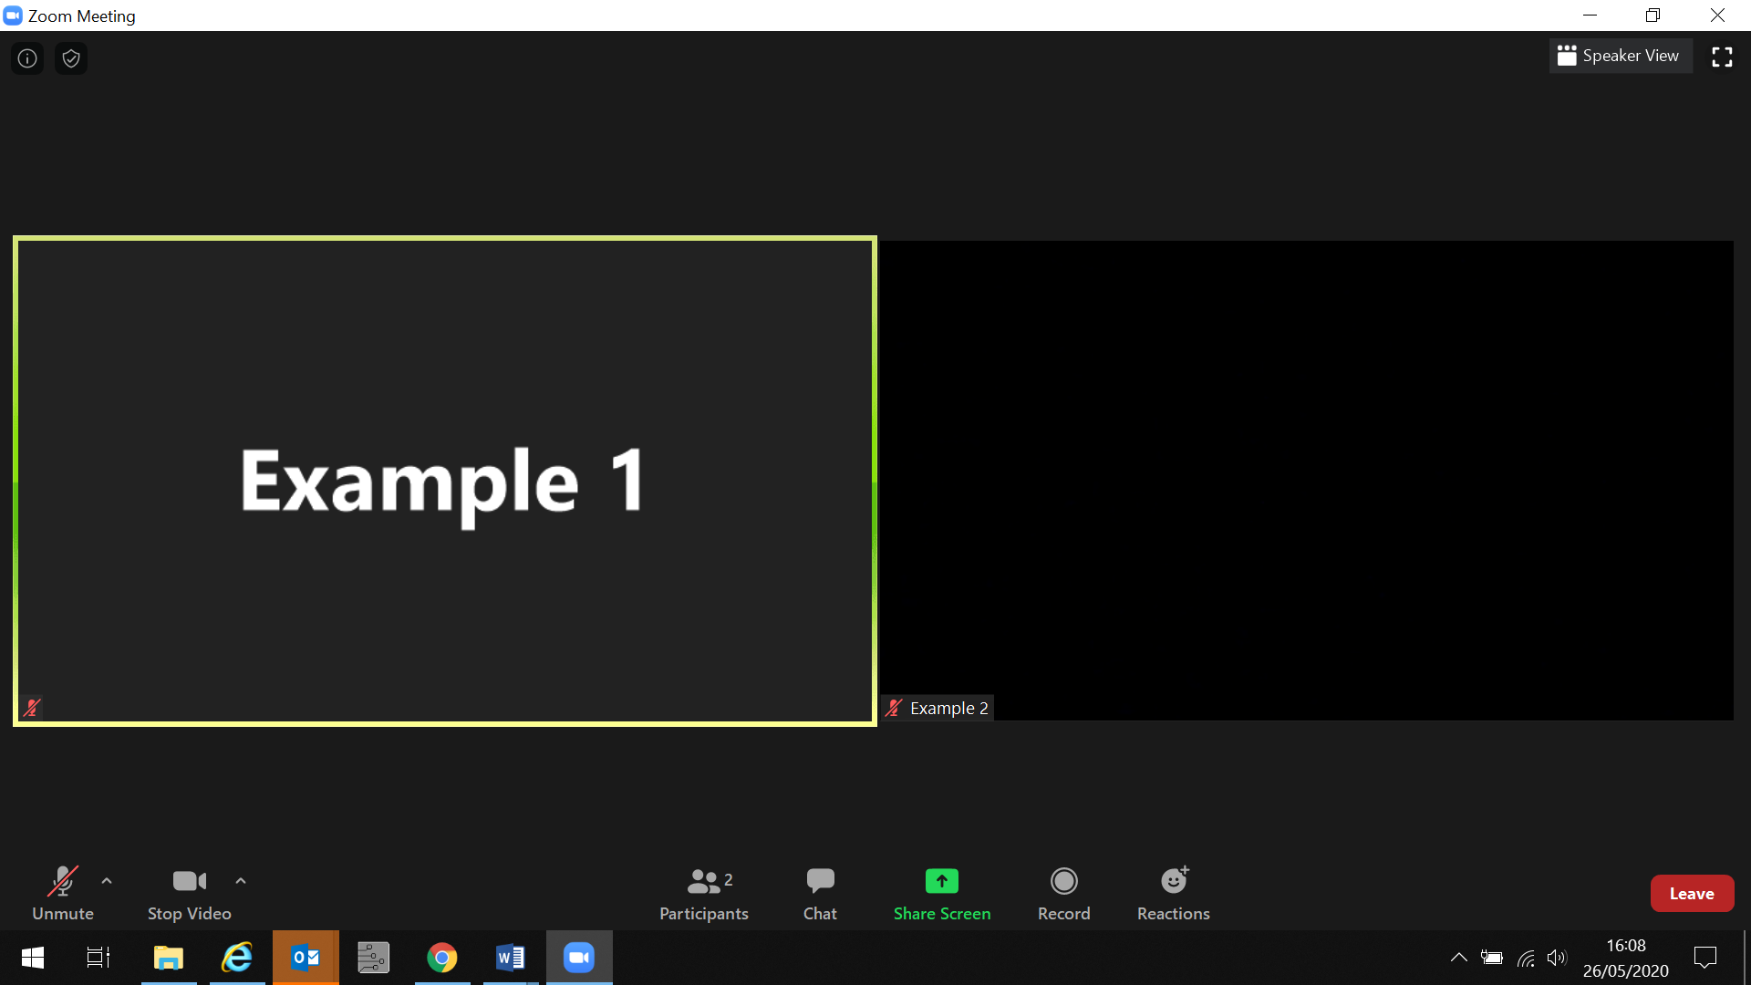

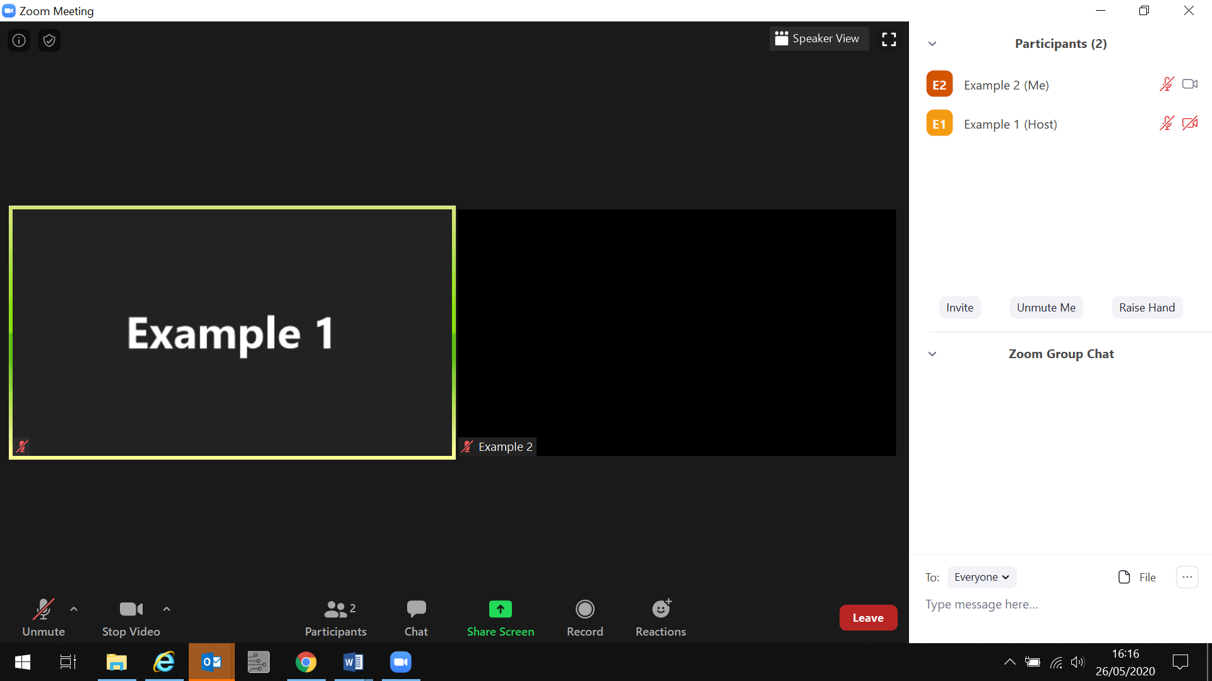

You can click on Chat to type a message to your trainer, or respond to a question during the session. You can Raise Hand to obtain the attention of your trainer and by placing your cursor over your name you will have the option to change your name if you wish to.

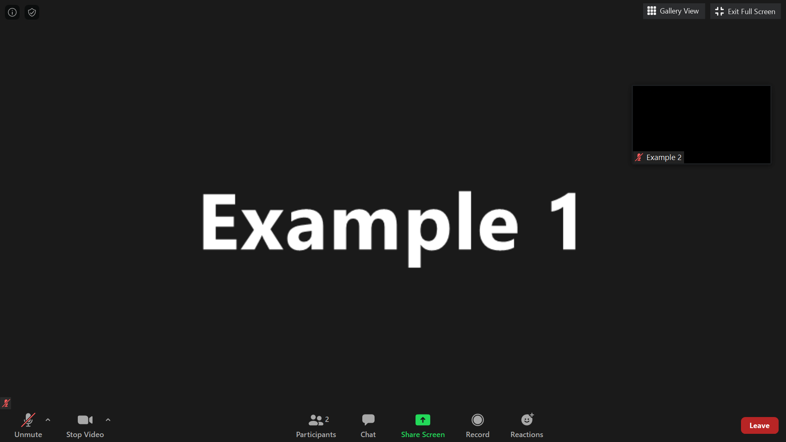

You can change your view from Gallery which shows all videos on your screen to Speaker view which will centralise your trainer as the main view on your screen.

Leave function is accessible at the bottom of your screen.