Joining a Zoom meeting from an android phone

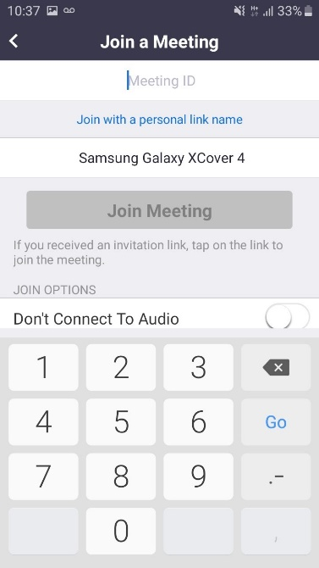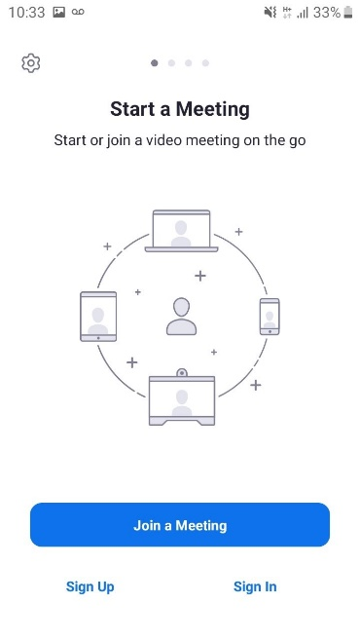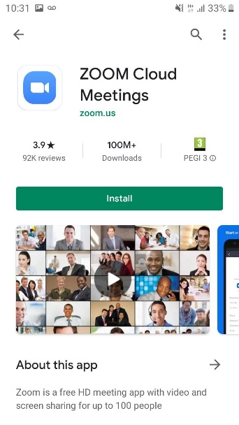

Enter the Meeting ID provided to you by the college

When you open Zoom, this will come up. Click Join a meeting.

To download Zoom, go to play store and type in Zoom.

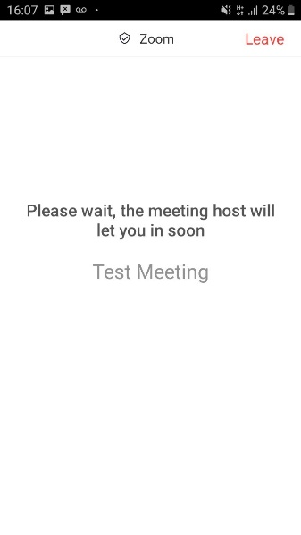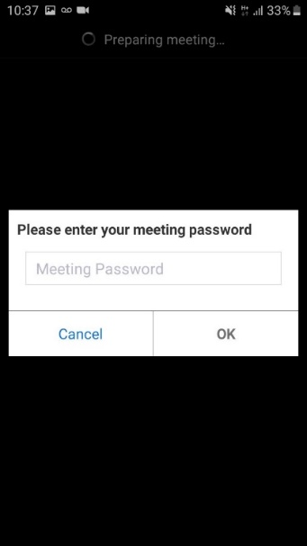

Enter the Meeting password provided to you by the college

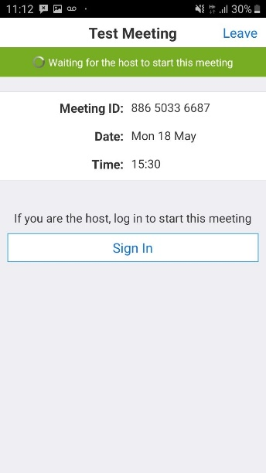

This is what you will see if you are in the waiting room

This is what you will see if we haven’t started the meeting yet

Basic Zoom functions from an android phone

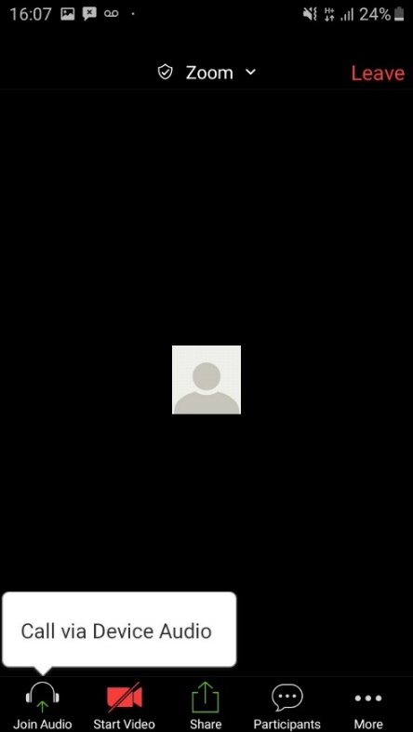

You can start or stop your video using this function



You can start or stop your audio using this function

This is how your screen will look when in the meeting if no videos are shown. Host videos will be shown. Students have the choice.

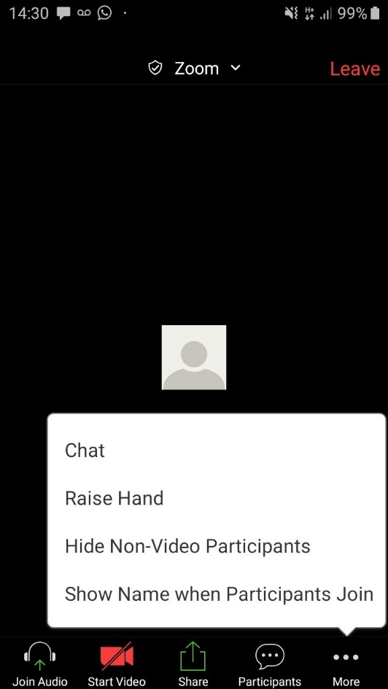

At the bottom of your screen, you can see three dots ‘more’. When you click that you

* can raise your hand to get trainers attention
* chat (there is a separate chat function which trainers will show you when the course starts)
* Hide non-video participants
* Show your name (you should be able to amend your name here too) This will also be shown with trainers when course starts