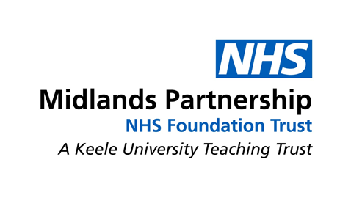

Private and Confidential
Wellbeing and Recovery College
St Georges Hospital
Corporation Street
Stafford
ST16 3AG

Date: 27th May 2020

Dear Students

Further to our email of Friday 22nd May 2020, we are writing to let you know that on Monday 18th May the student weekly update was sent out via email using outlook and unfortunately all email addresses were shown on that email. Please delete this email from your mailbox and further delete it from your deleted mailbox. If you can confirm that this has been done it would be much appreciated.

In line with Trust procedures this has been recorded as an Incident and notified to the Trust Information Governance Team. The aim of which is to ensure that any underlying cause is identified, working practices are reviewed, and measures implemented to mitigate the possibility of this happening again.

An investigation has been undertaken identifying that a system error occurred during the outlook email process. Therefore, any future email updates will be sent via the Mind Recovery Net database, which is a dedicated database for the Wellbeing and Recovery College Service. This change in process will mitigate the risk of this type of incident from reoccurring in the future.

If you are not satisfied with this outcome you can make a complaint using the links on our website or by writing to the address below.

Neil Carr
Trust Headquarters
St. George’s Hospital
Corporation Street
Stafford
ST16 3SR

Yours sincerely

Wellbeing and Recovery College

